School Name
Mathematics Test 2017
Year 10 |  | Non-Right Triangle Trigonometry | Calculator Allowed
Skills and Knowledge Assessed:  - Apply Pythagoras’ theorem and trigonometry to solving three - dimensional problems in right- angled triangles (ACMMG276)  - Use the unit circle to define trigonometric functions, and graph them with and without the use of digital technologies (ACMMG274)  - Solve simple trigonometric equations (ACMMG275)  - Establish the sine, cosine and area rules for any triangle and solve related problems (ACMMG273) |  |  | Name_________________
Section 1 Short Answer Section
Write all working and answers in the spaces provided on this test paper.

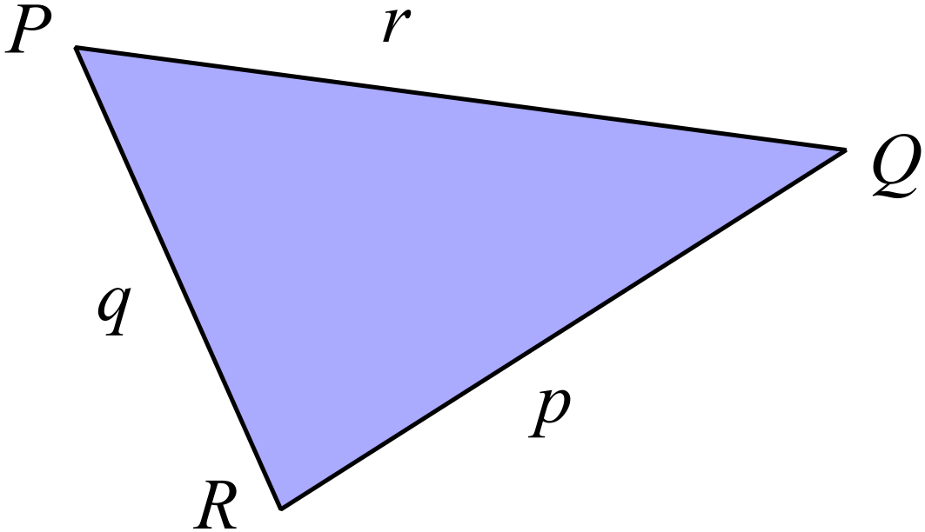Complete the statement of the cosine rule below for ∆PQR?

……………………………………………....

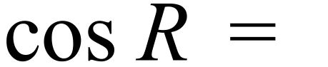 …………………………

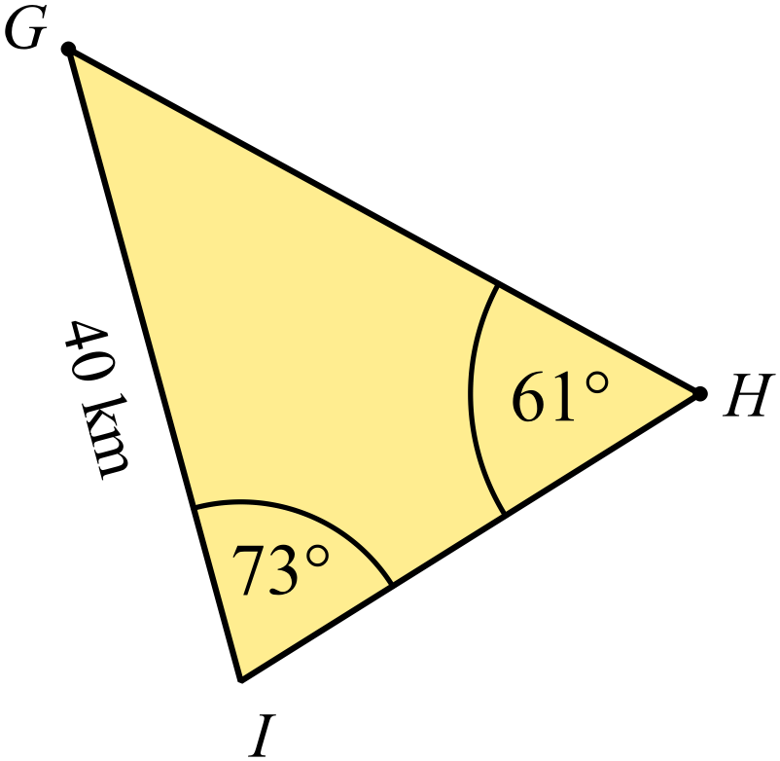Write a statement of the sine rule which could be used to
find the distance GH ?
(You do not need to complete the calculation and find GH.)

………………………………………………

……………………………………………....

………………………………………………

……………………………………………….
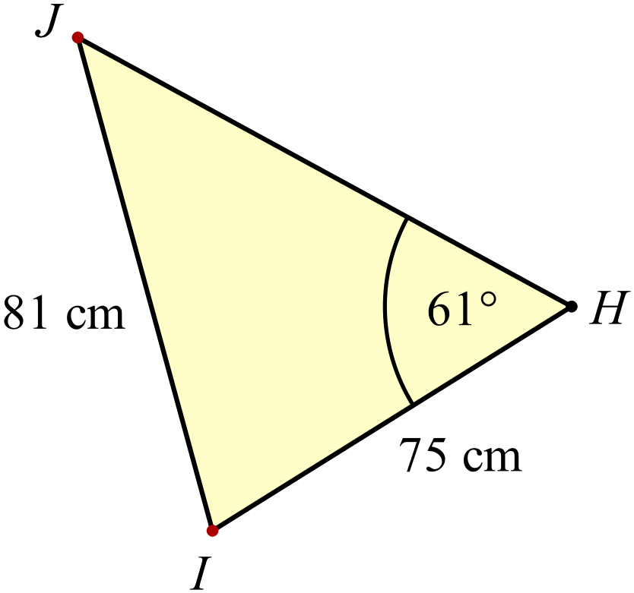Find the size of 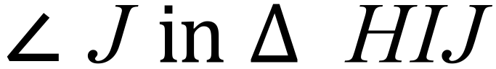, correct to the nearest degree.

………………………………………………

……………………………………………....

………………………………………………

……………………………………………….
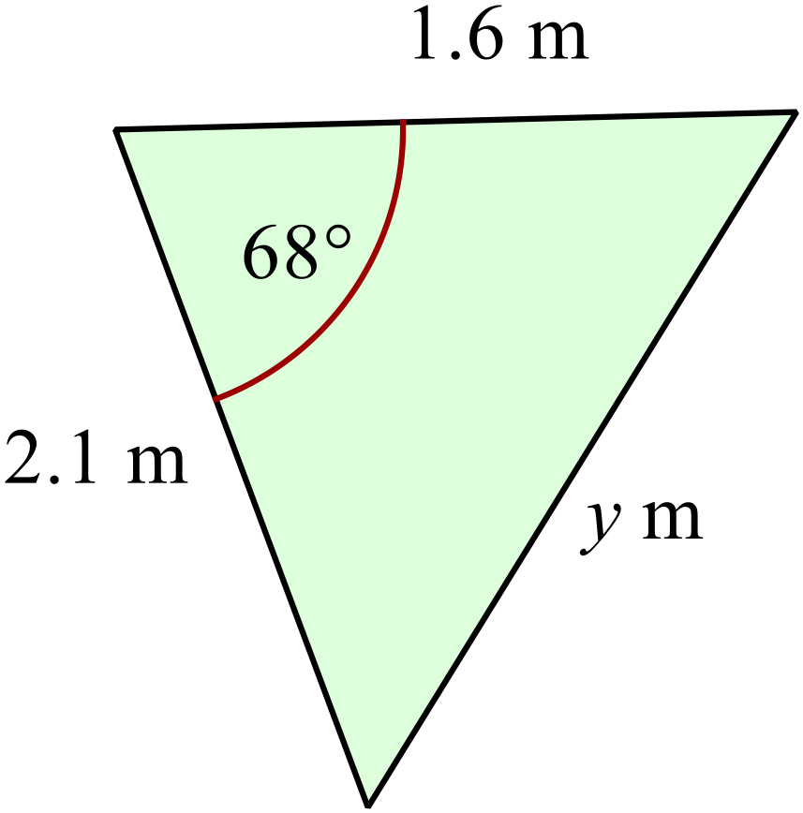Use the cosine rule to find the value of w, correct to 2 significant figures.

………………………………………………

………………………………………………

……………………………………………....

………………………………………………

……………………………………………….
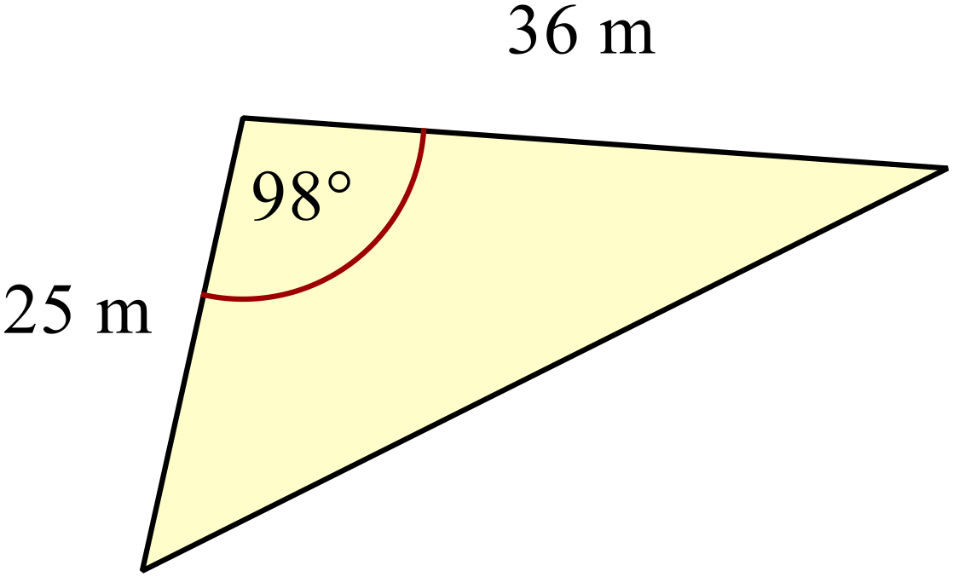Find the area of the triangle shown.

………………………………………………

……………………………………………....

………………………………………………

……………………………………………….
Solve

………………………………………………

……………………………………………....

………………………………………………

……………………………………………….
Calculate the value of 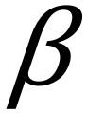 correct to the nearest degree.
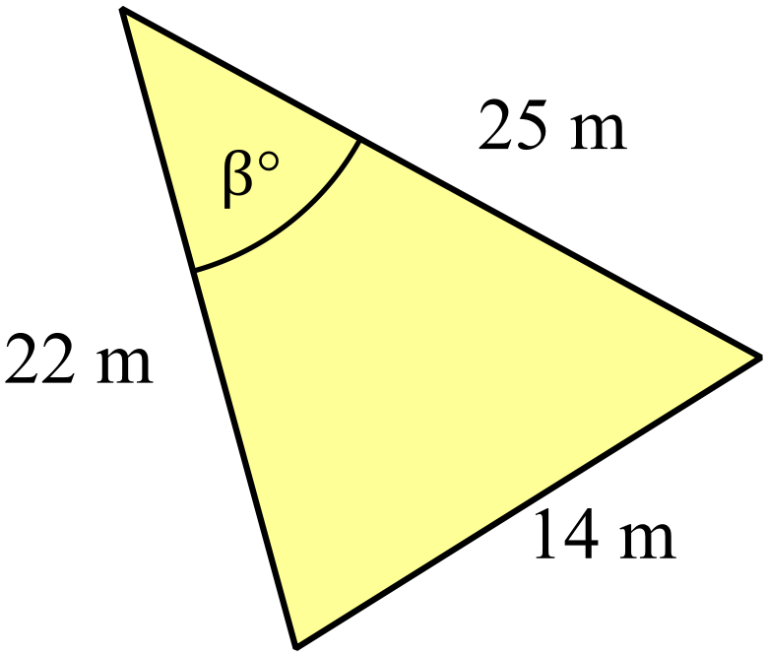

………………………………………………

……………………………………………....

………………………………………………

……………………………………………….
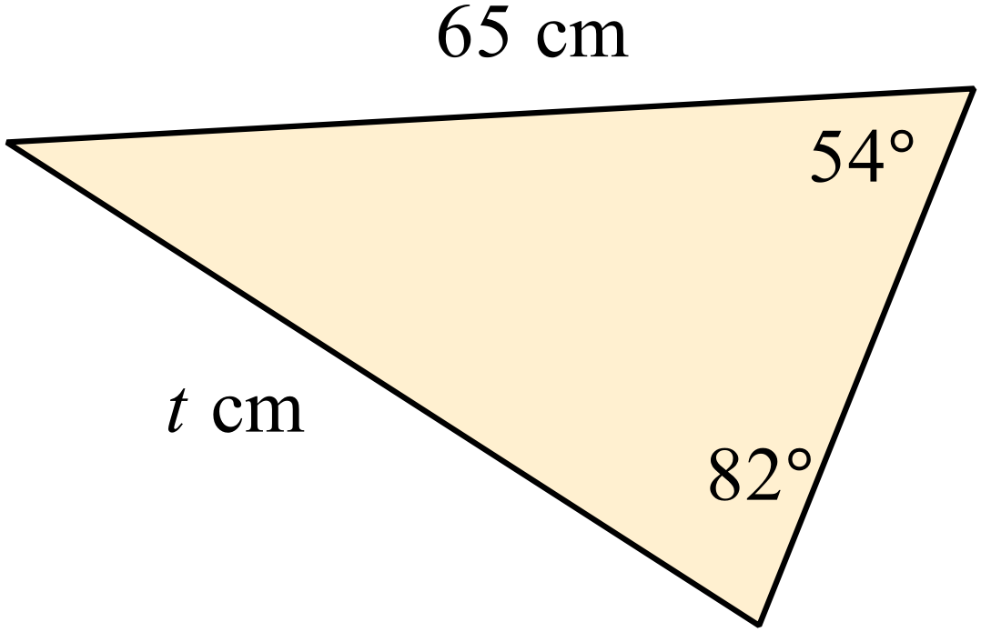Find the value of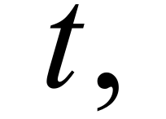to the nearest millimetre.

………………………………………………

……………………………………………....

………………………………………………

……………………………………………….
Find the area of this triangle, correct to the nearest square centimetre.
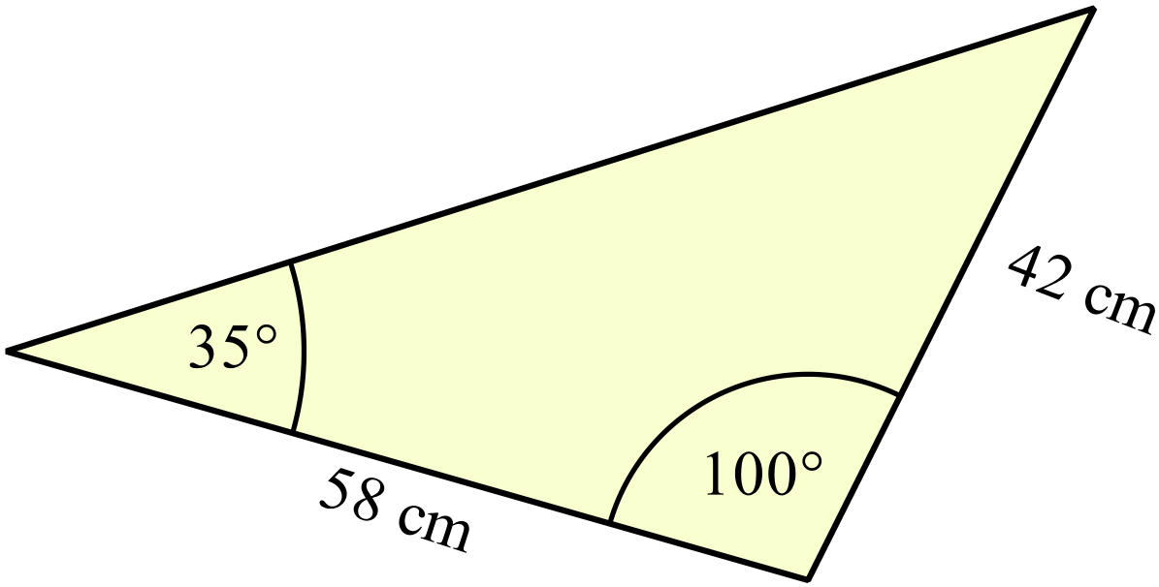

………………………………………………

……………………………………………....

………………………………………………

……………………………………………….
In the rectangular prism shown, TU = 150 cm UX = 80 cm and UY = 120 cm.
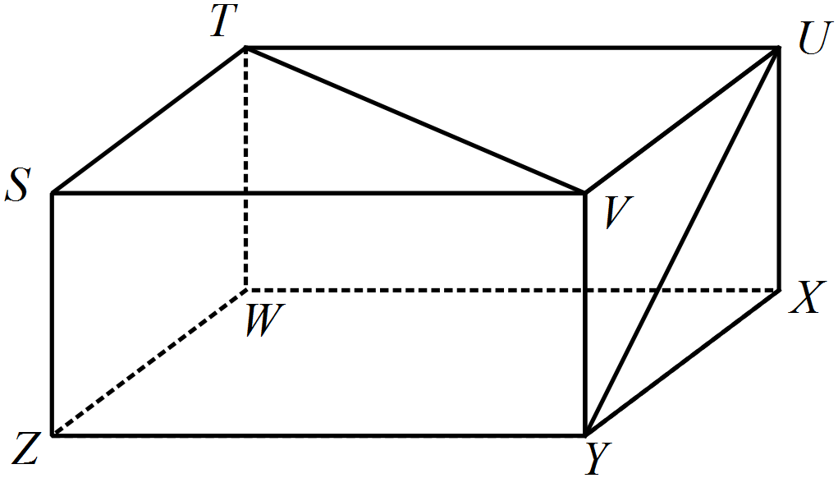Find the size of 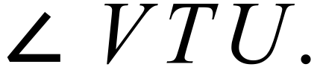

………………………………………………

……………………………………………....

………………………………………………

……………………………………………….
A lighthouse N is on top of a cliff.
The direct distance from ship S to N is 4100 m and from ship T to N is 3600 m.
The two ships are in a straight line to the lighthouse and are 900 m apart.
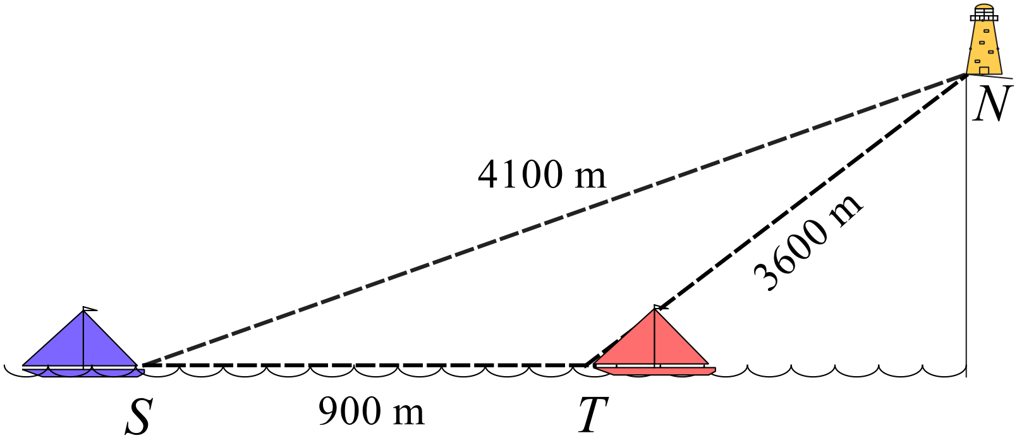What is the angle of elevation of the lighthouse from ship T?

………………………………………………

……………………………………………....

………………………………………………

……………………………………………….
Complete the table below and use it to draw a sketch of 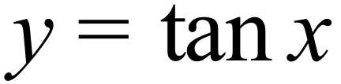 for 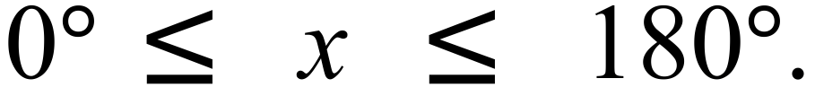

x | 0º | 30º | 45º | 60º | 90º | 120º | 135º | 150º | 180º
tan x
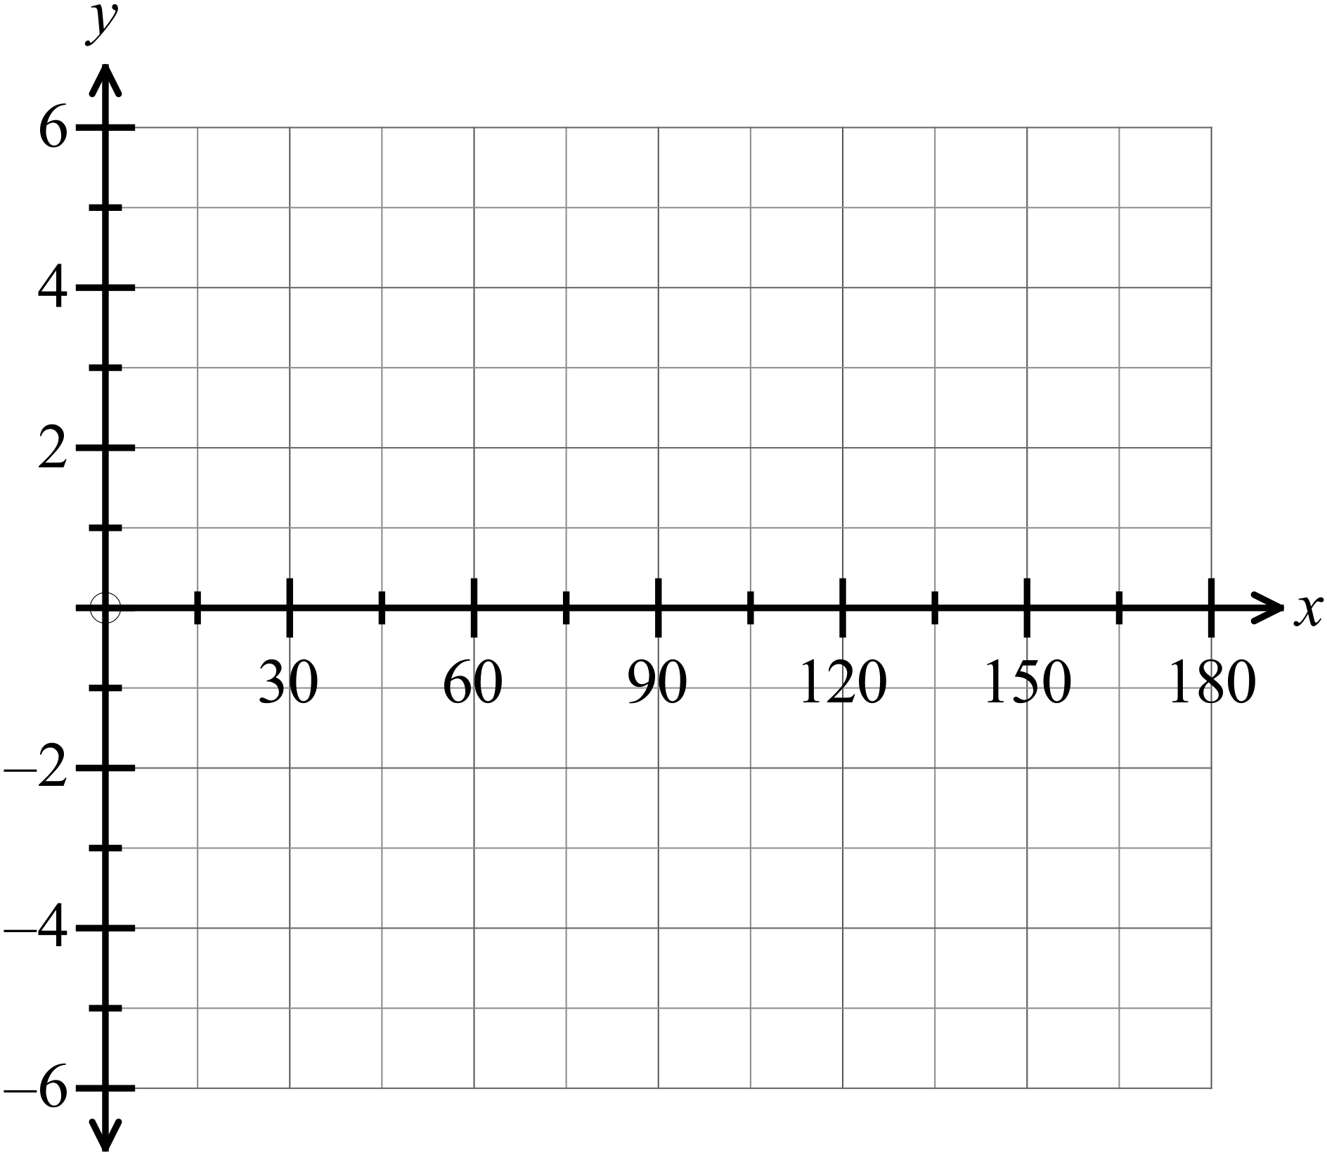

Ship R is 200 km on a bearing of 048º from Port P.
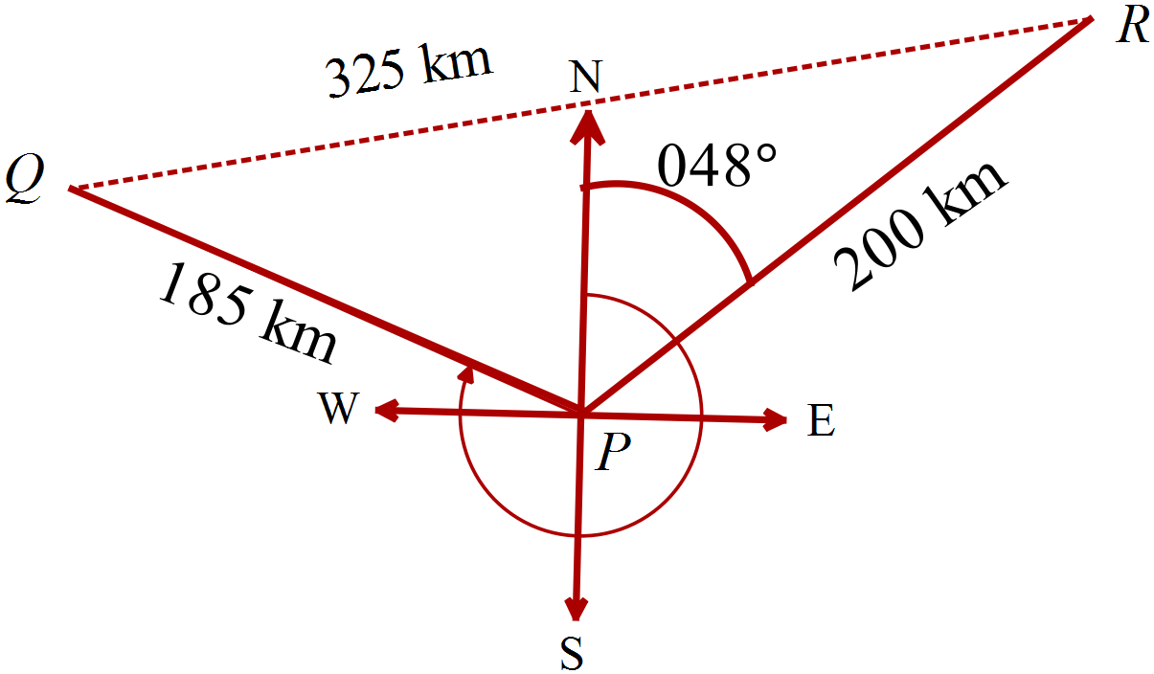Ship Q is 185 km from Port P.
Ships Q and R are 325 km apart.
Calculate the bearing of Q from P.

………………………………………………

……………………………………………....

………………………………………………

……………………………………………….
Given that 
Find the values of x if 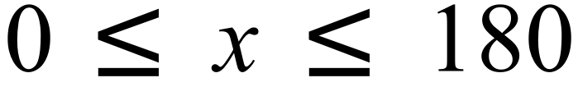.

……………………………………………………………………………………………....

………………………………………………………………………………………………

.……………………………………………………………………………………………....

……………………………………………………………………………………………….
A tower VX has an angle of elevation of 20º when viewed from U which is 150 m away from X on level ground.
It has an angle of elevation of 28º when viewed from W which is in the same plane as U and X.
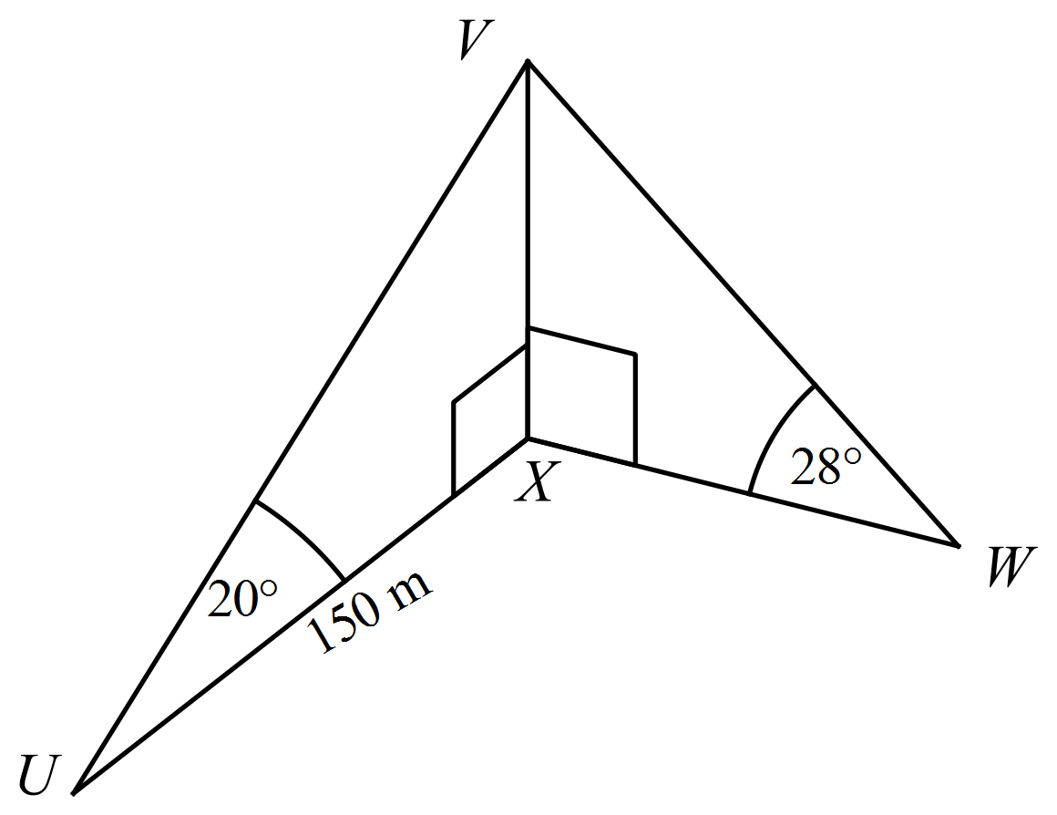
How far is W from X?
…………………………………………....

………………………………………………

………………………………………………

……………………………………………....

………………………………………………

……………………………………………….

School Name
Mathematics Test 2017
Year 10 |  | Non-Right Triangle Trigonometry | Calculator Allowed
 |  | Non-Right Triangle Trigonometry | Name_________________
Section 2 Multiple Choice Section
Mark all your answers on the accompanying multiple choice answer sheet, not on this test paper. You may do any working out on this test paper. Calculators are allowed for this section.

Which of the following could not be used to find the size of 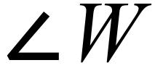 in 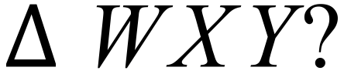

A. 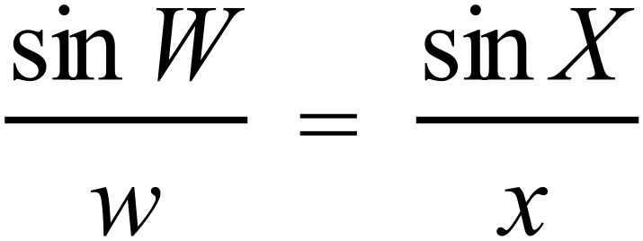
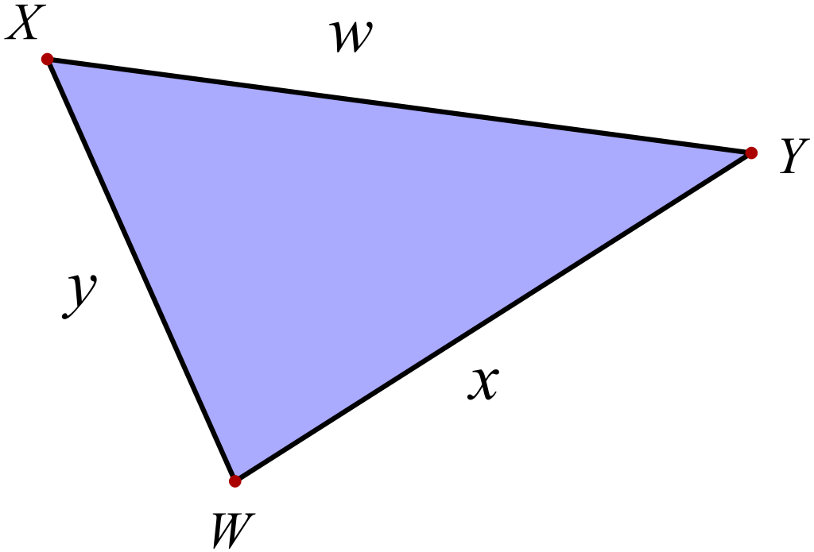 B. 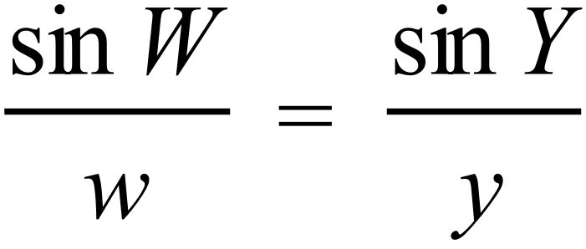
C. 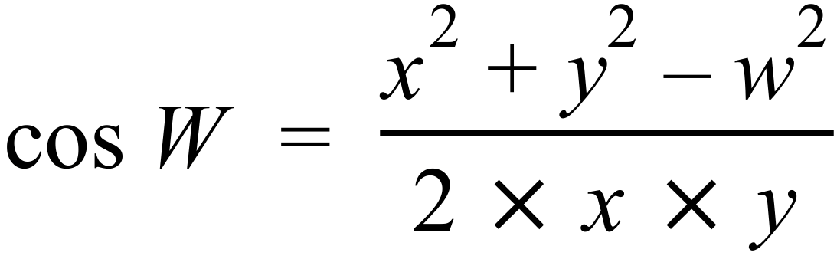
D. 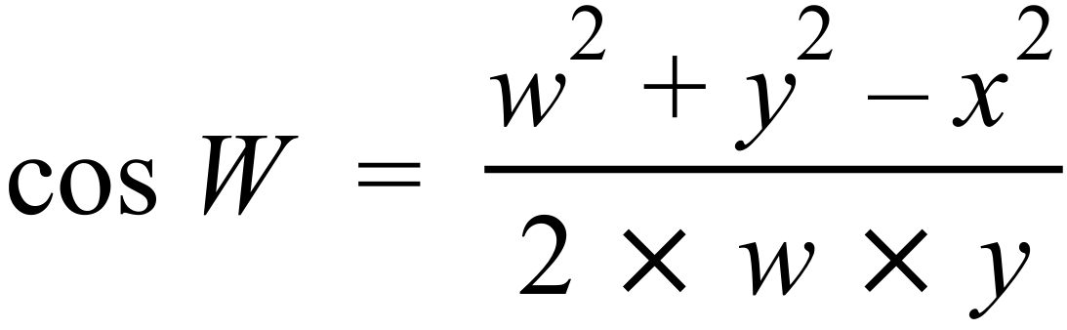
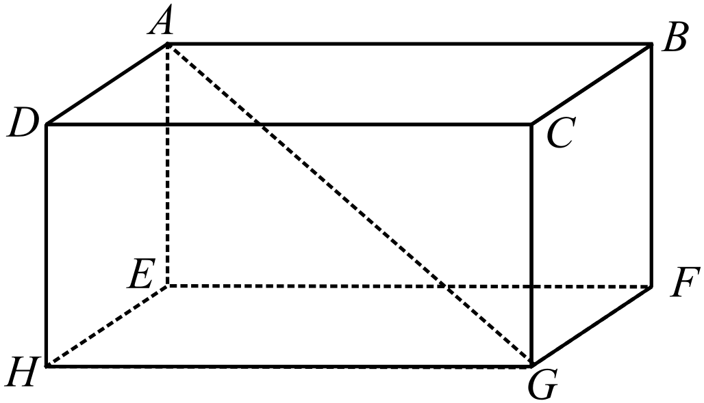Which expression could be used to find the length of the diagonal AG in the rectangular prism shown.

A. 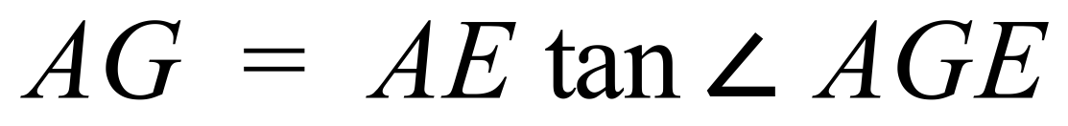
B. 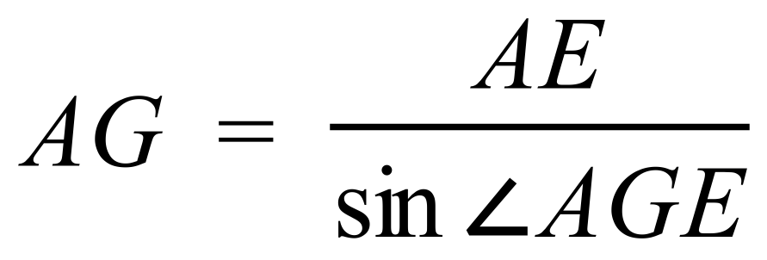
C. 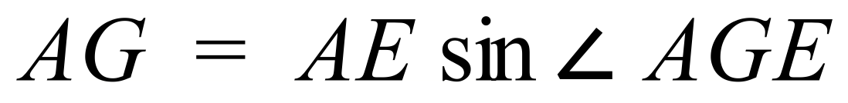
D. 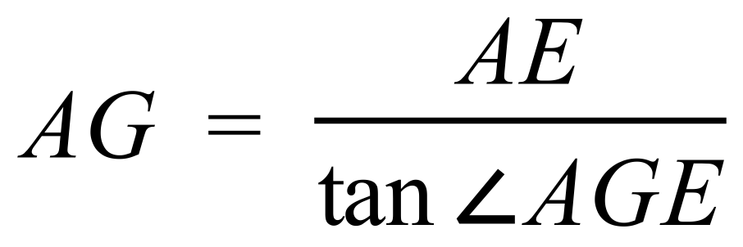

Use the sine rule to find the size of 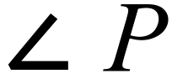 correct to the nearest degree.
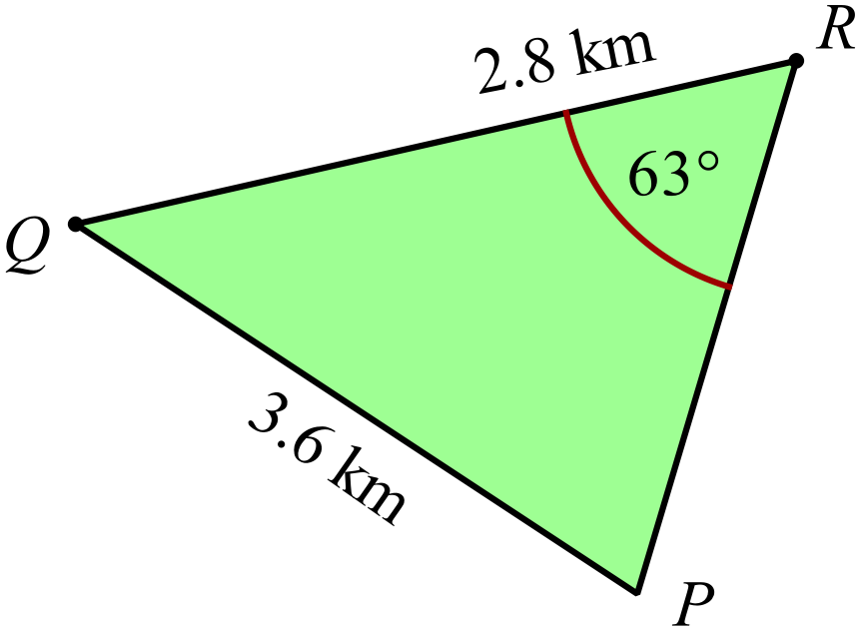

A. 21º
B. 40º
C. 44º
D. 46º
Use the cosine rule to find the value of x, correct to the nearest metre.
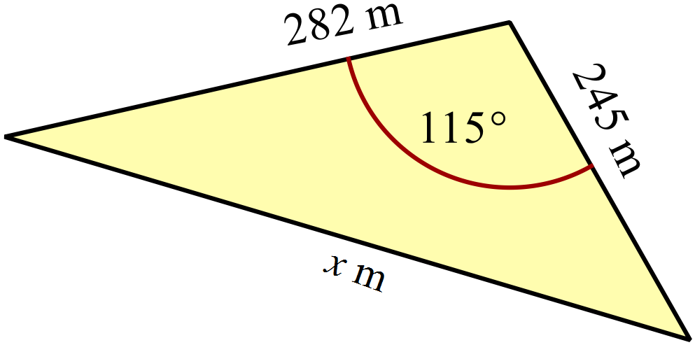

A. x = 119
B. x = 180
C. x = 410
D. x = 445
Which equation would best describe the graph shown below?
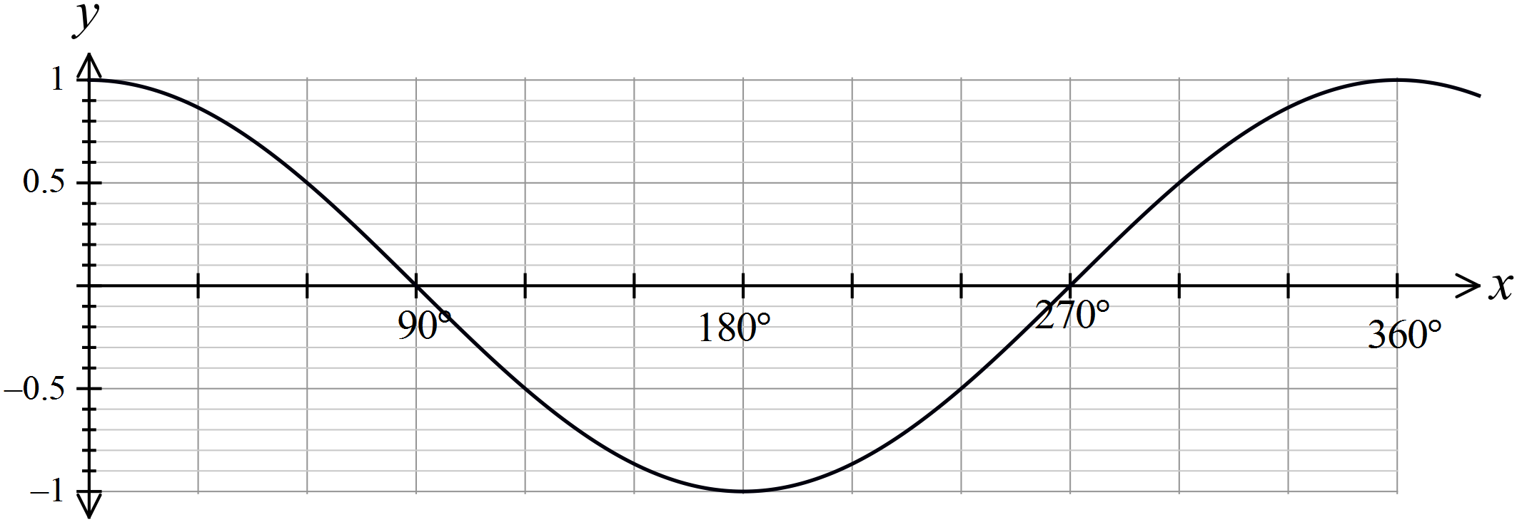

A. 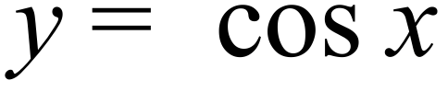
B. 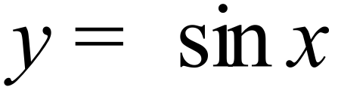
C. 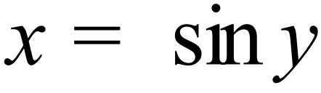
D. 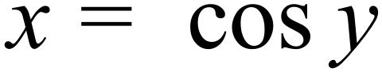
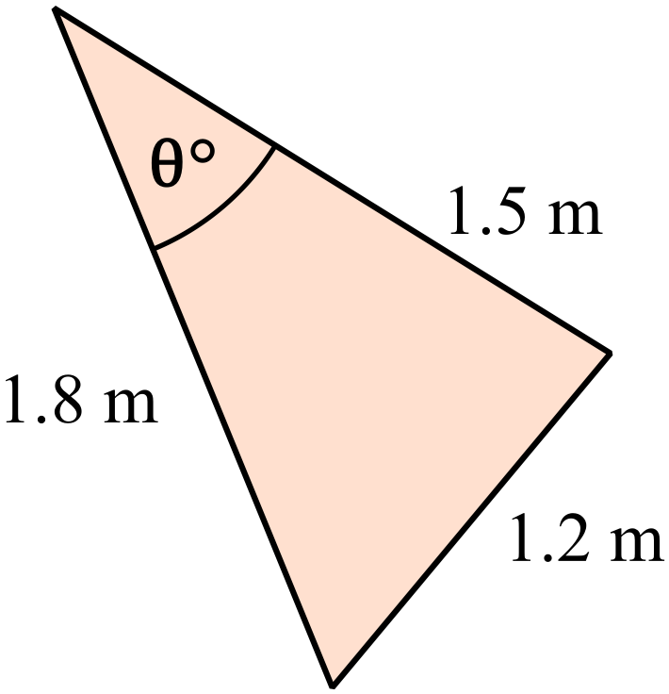What is the value of 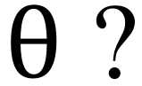

A. 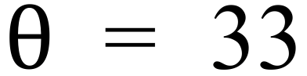
B. 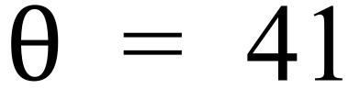
C. 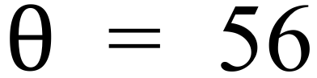
D. 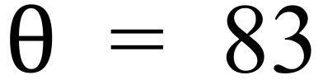

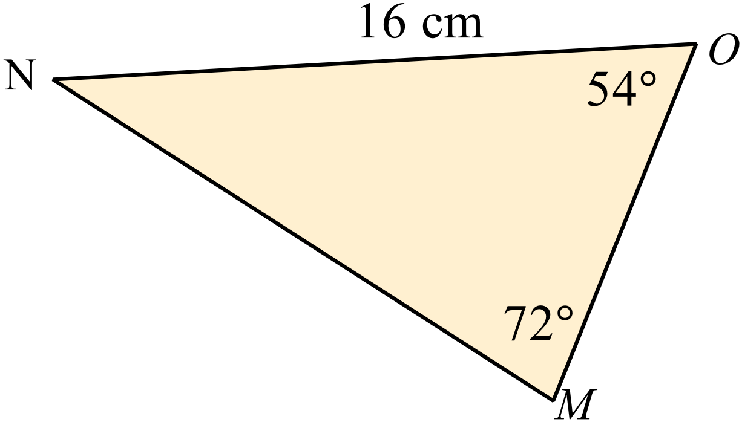Find the length of the side MN.

A. 3.7 cm
B. 12.9 cm
C. 13.6 cm
D. 18.8 cm

Find the area of 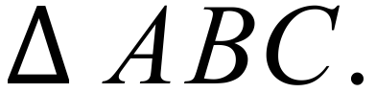
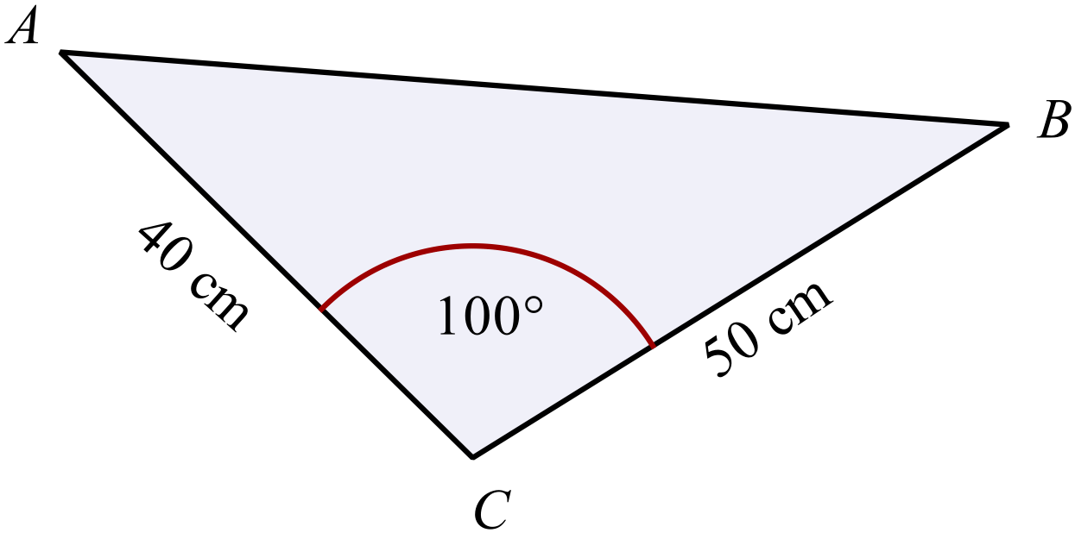Answer to the nearest cm².

A. 985 cm²
B. 995 cm²
C. 1000 cm²
D. 1970 cm²
Find the value of 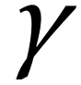 between 0º and 90º such that 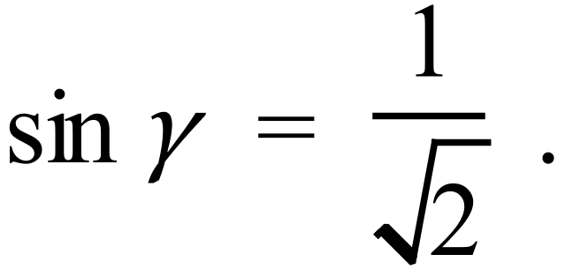
Answer to the nearest degree.

A. 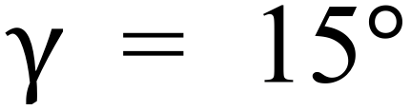
B. 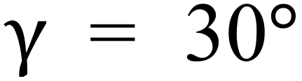
C. 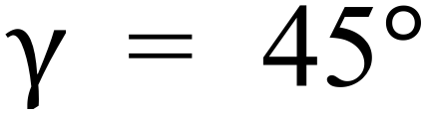
D. 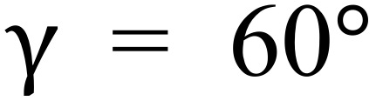
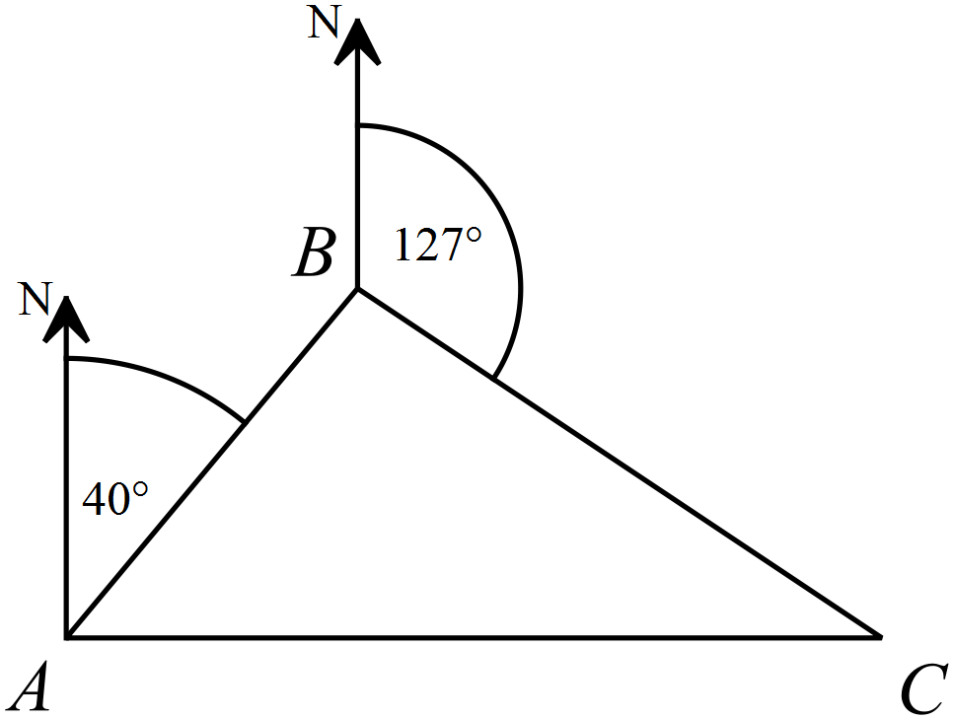Three points A, B and C are shown on a map,
along with the compass bearings of two of the points

What is the size of 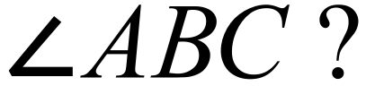

A. 63º
B. 83º
C. 87º
D. 93º
In
Calculate the size of 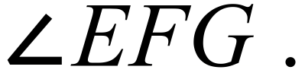
A. 45º
B. 52º
C. 62º
D. 65º
Two hikers leave the same camp ground at the same time.
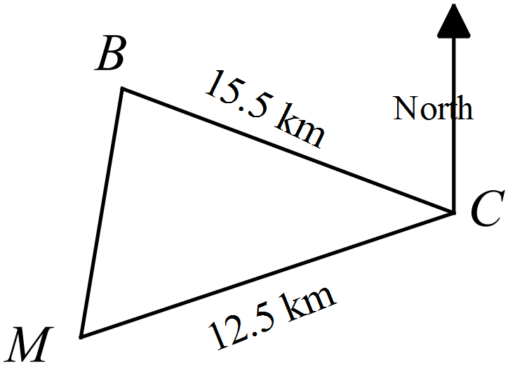Michael hikes 12.5 km on a bearing 220º.
Ben hikes 15.5 km on a bearing 295º.
How far apart are the two hikers?
A. 4.0 km
B. 8.3 km
C. 17.2 km
D. 18.6 km
If which statement describes all the possible values of

A. 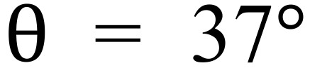 only.
B. 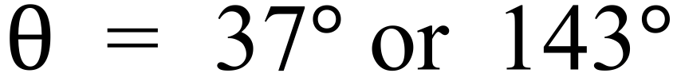.
C. 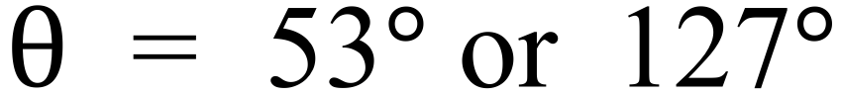
D. 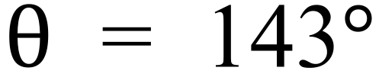 only.
The diagram shows two right angled triangles which share a common side BC in 3 dimensions.
By first finding the length of BC, calculate the length of BD.
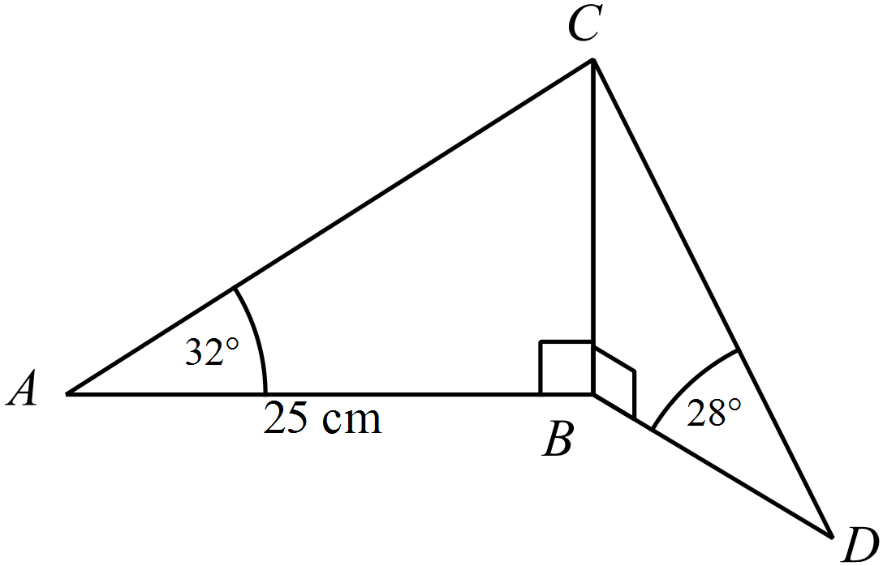

A. 11.7 cm
B. 22.1 cm
C. 28.2 cm
D. 29.4 cm

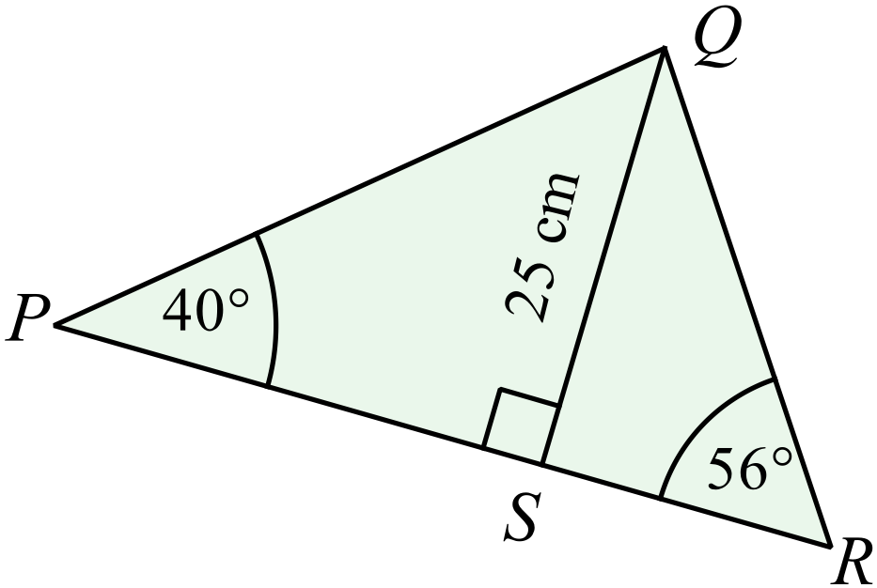In the 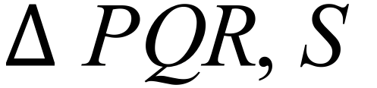 is a point on PR such that 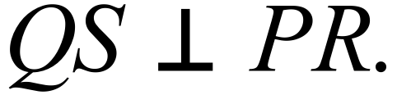
Find the length of PR, correct to the nearest mm.
A. 6.8 cm
B. 32.4 cm
C. 38.7 cm
D. 46.7 cm

School Name
Mathematics Test 2017
Multiple Choice Answer Sheet
Non-Right Triangle Trigonometry
Name _____________________________________________
Completely fill the response oval representing the most correct answer.
1. A B C D
2. A B C D
3. A B C D
4. A B C D
5. A B C D
6. A B C D
7. A B C D
8. A B C D
9. A B C D
10. A B C D
11. A B C D
12. A B C D
13. A B C D
14. A B C D
15. A B C D

School Name
Mathematics Test 2017
Year 10 | Non-Right Triangle Trigonometry | Non Calculator Section
ANSWERS

Question | Working and Answer
 | 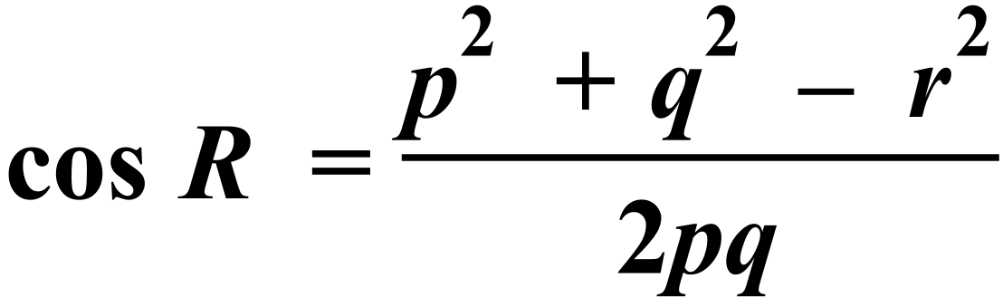
 | 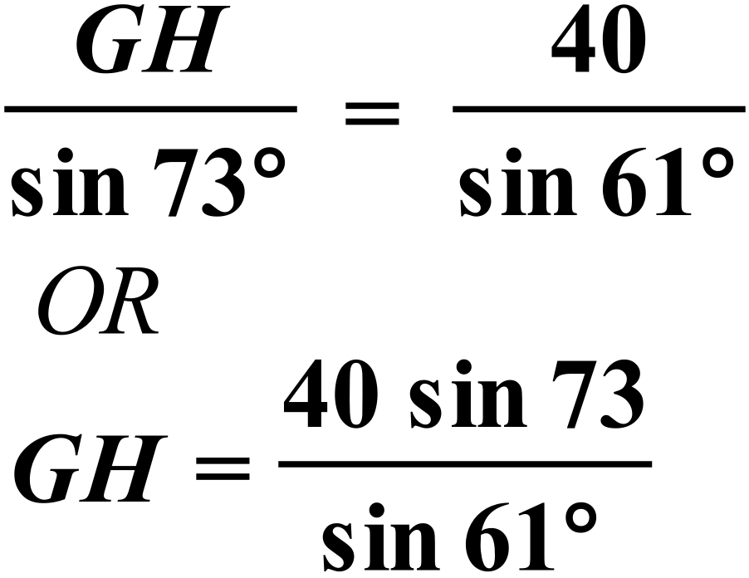
 | 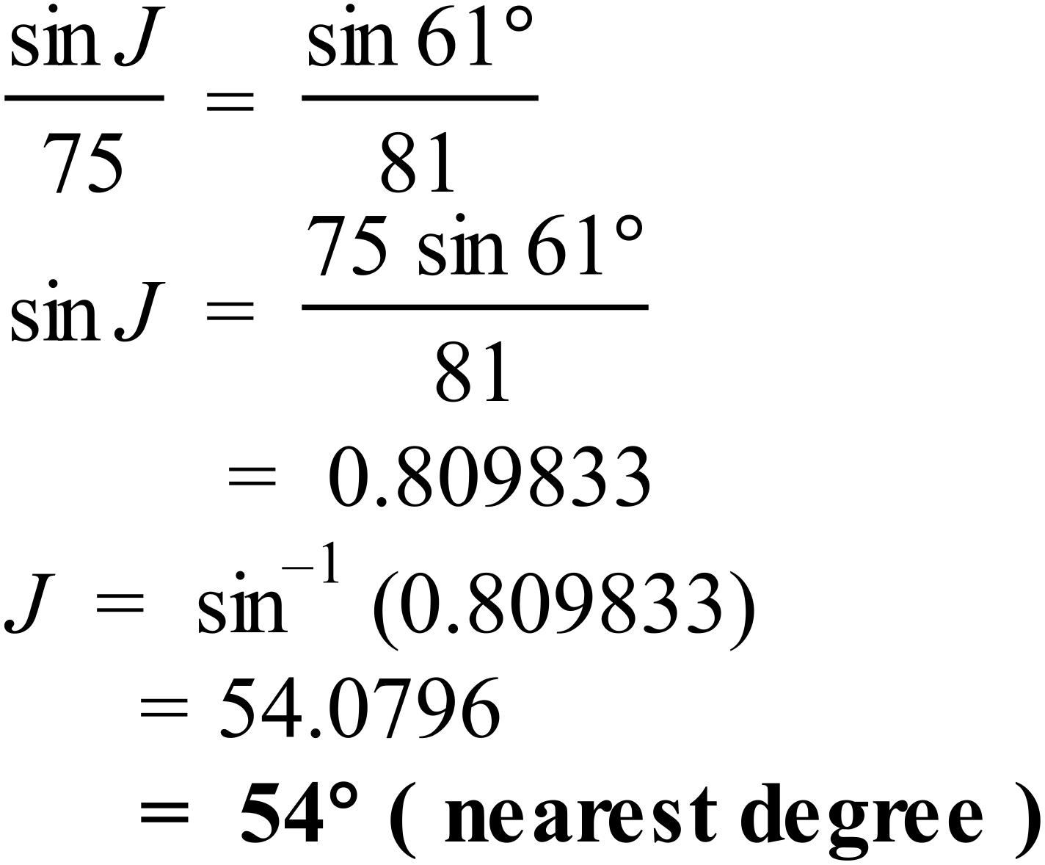
 | 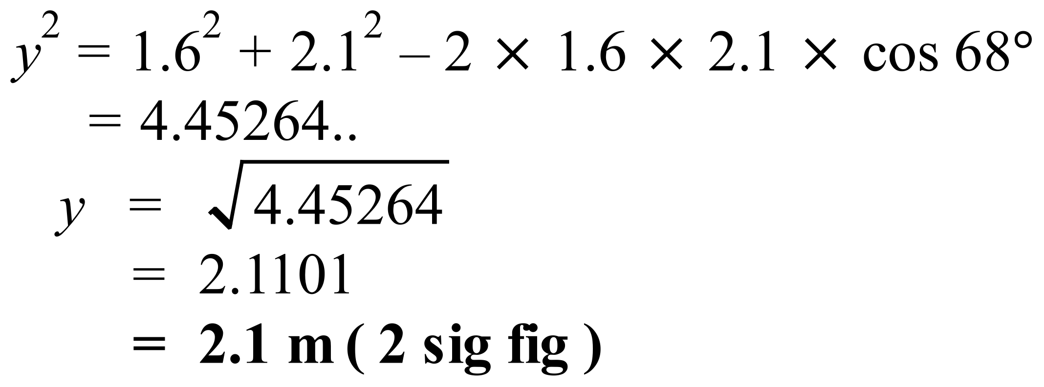
 | 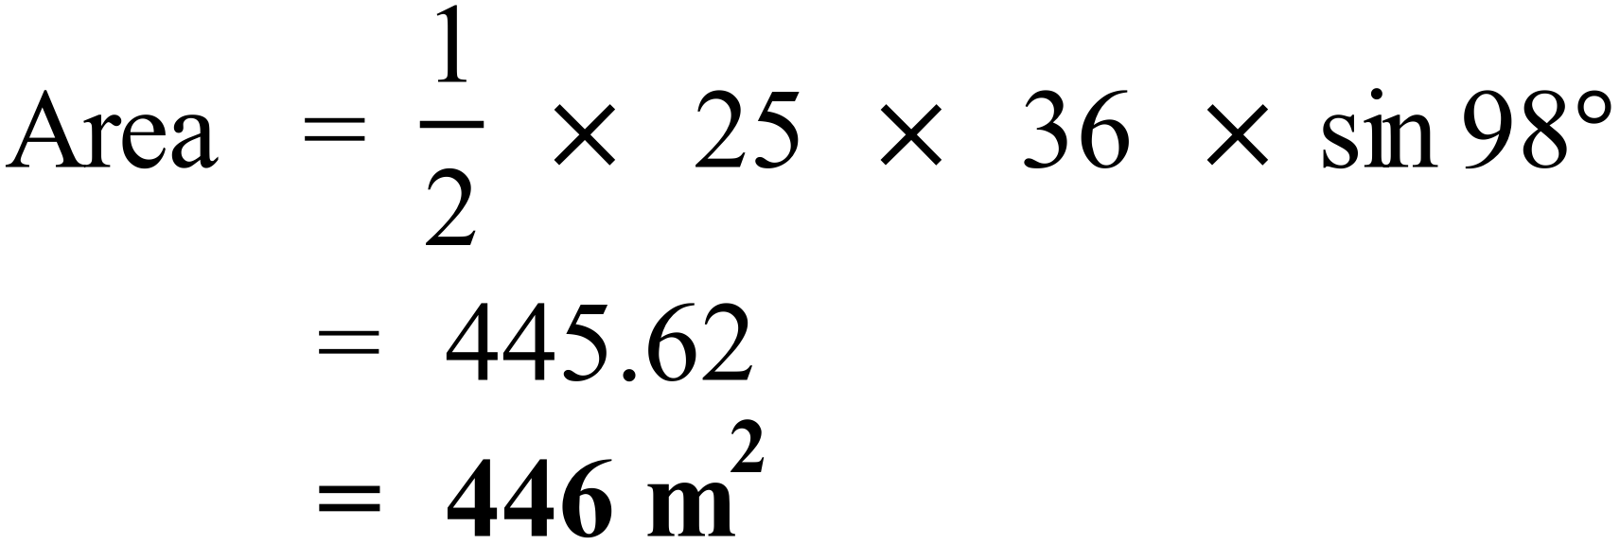
 | 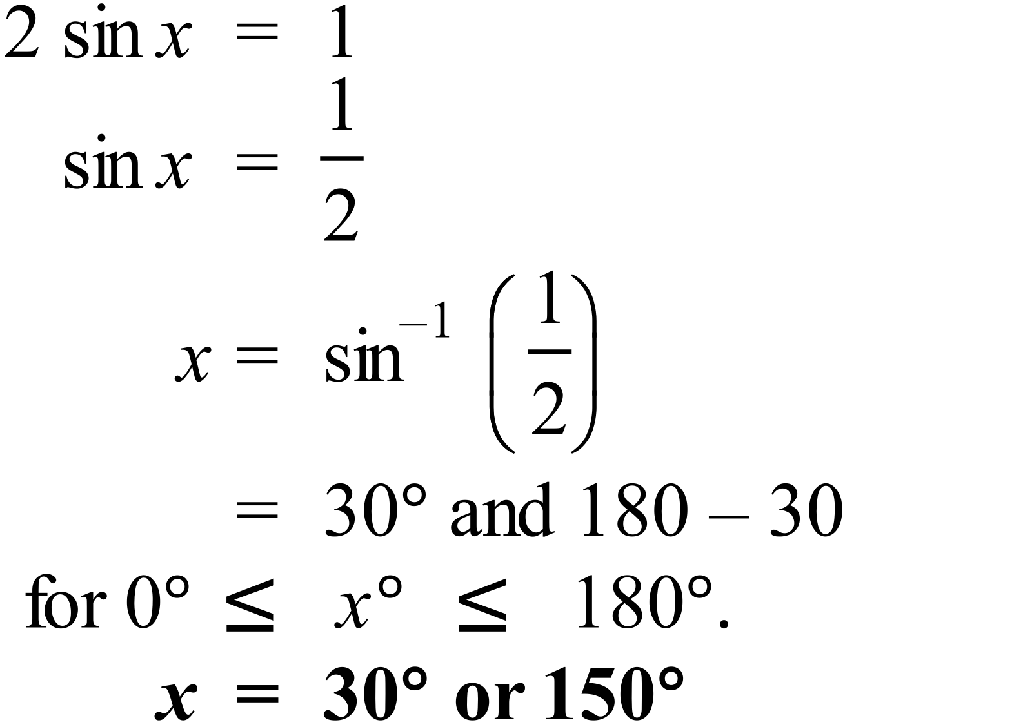
 | 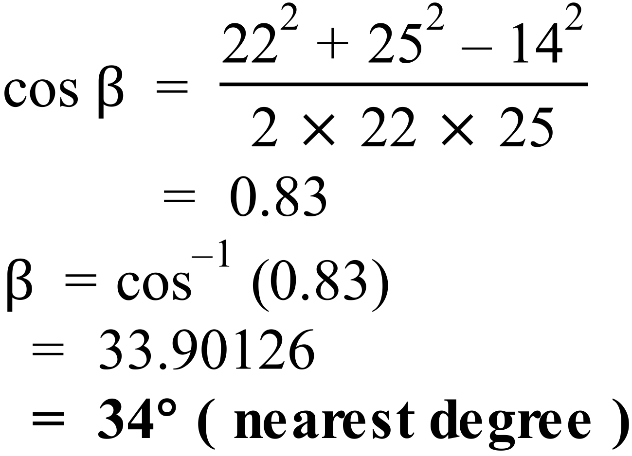
 | 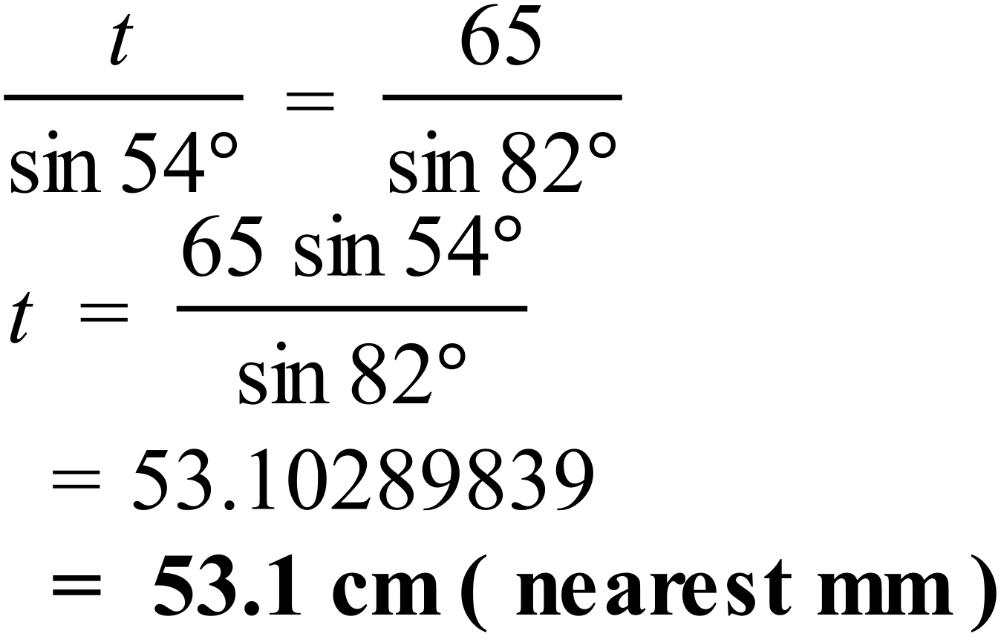
Need two sides and an included angle so use 100º angle.
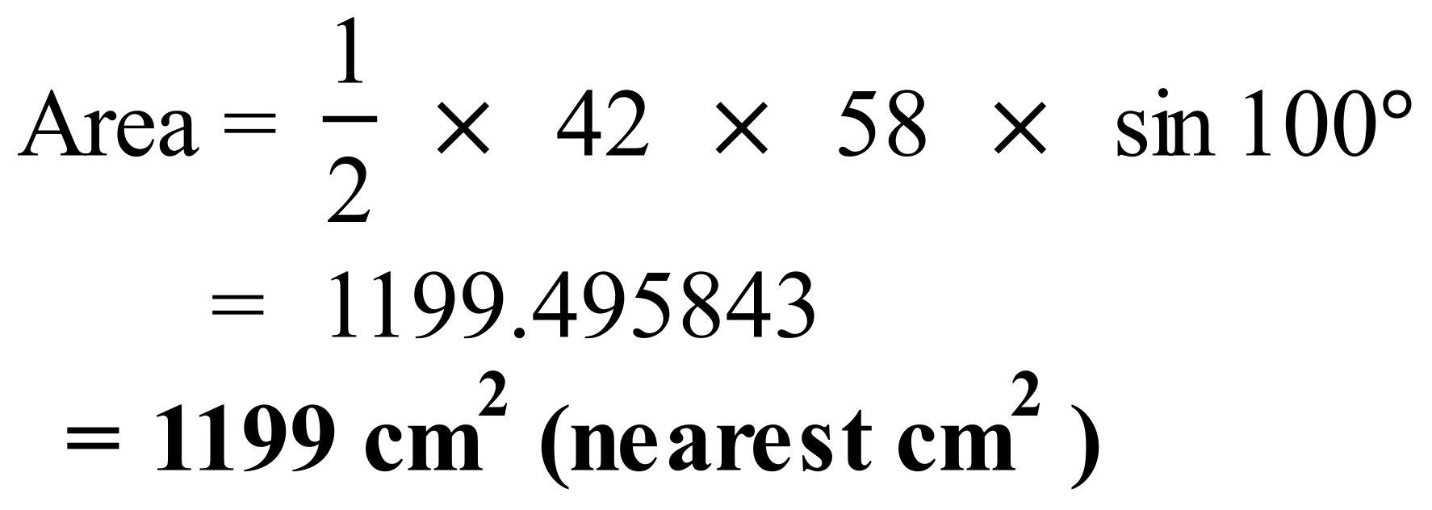
 | 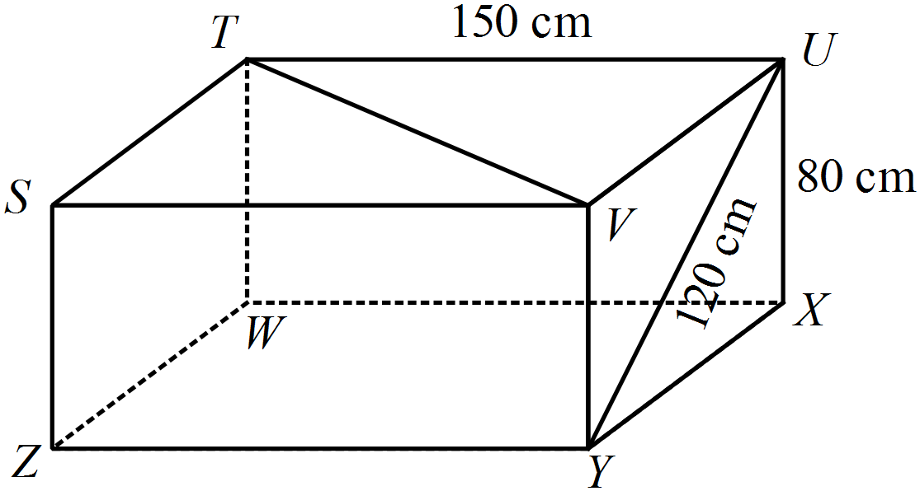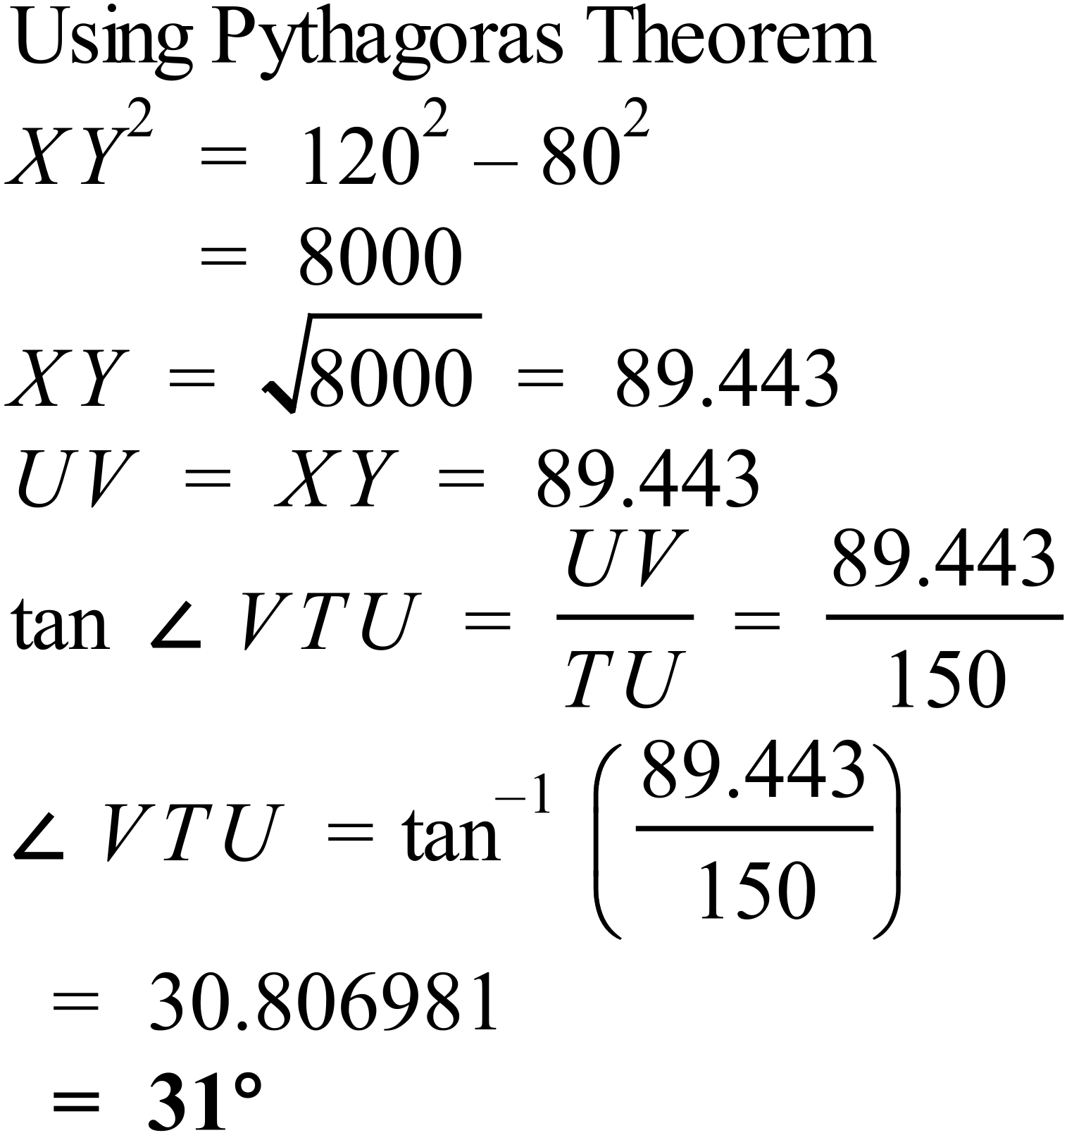
Need to find 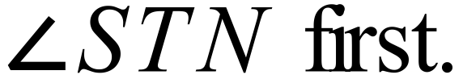
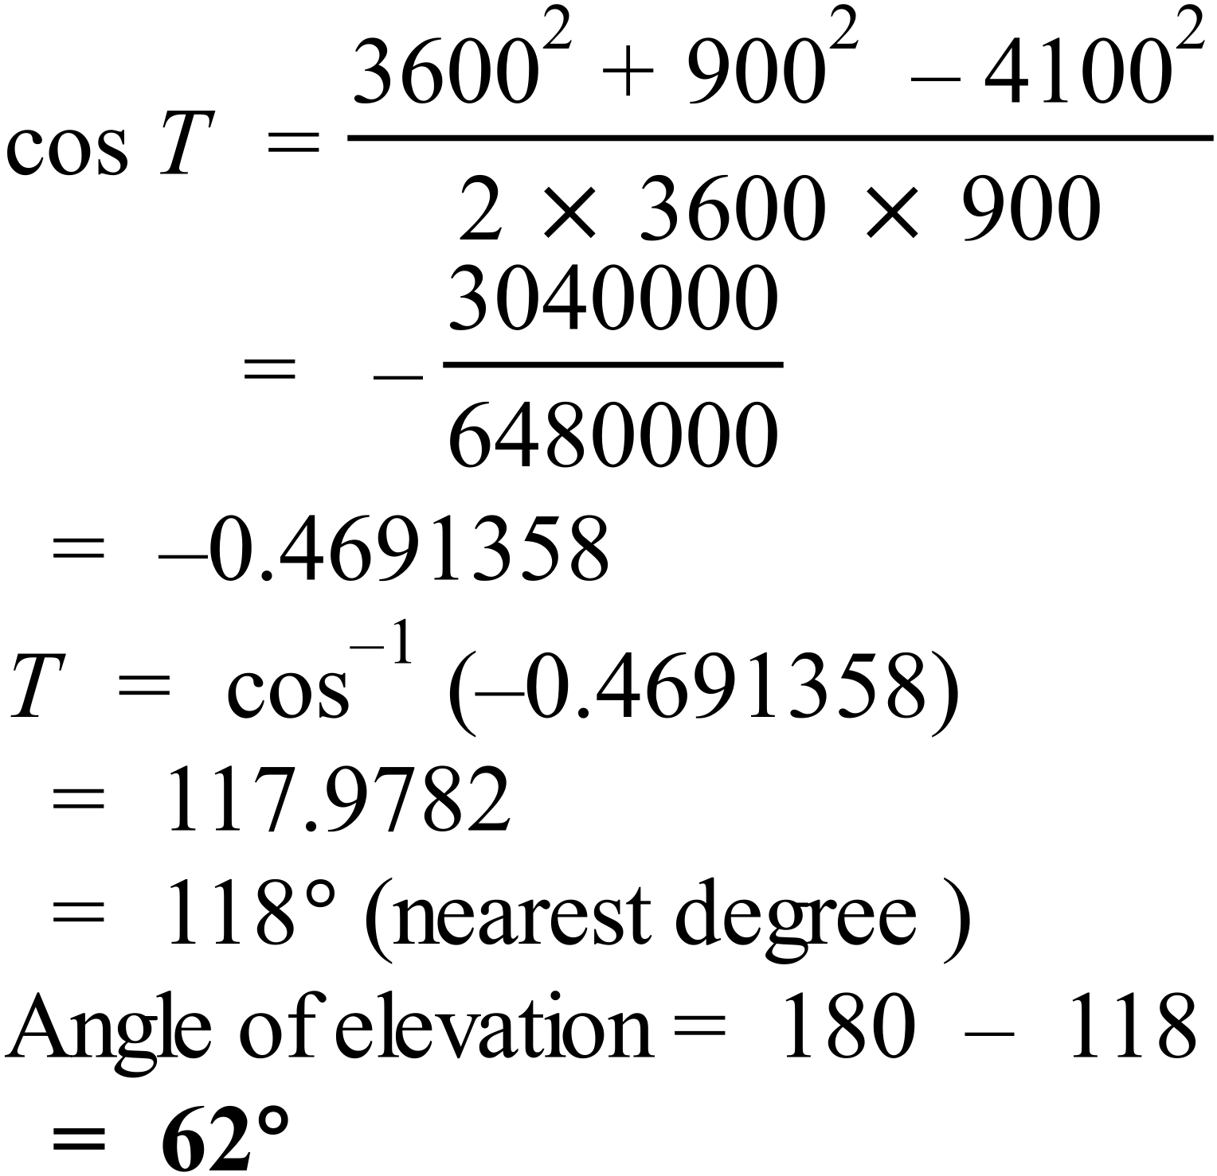

x | 0º | 30º | 45º | 60º | 90º | 120º | 135º | 150º | 180º
tan x | 0 | 0.577 | 1.00 | 1.732 | Undef | -1.732 | -1.00 | -0.577 | 0
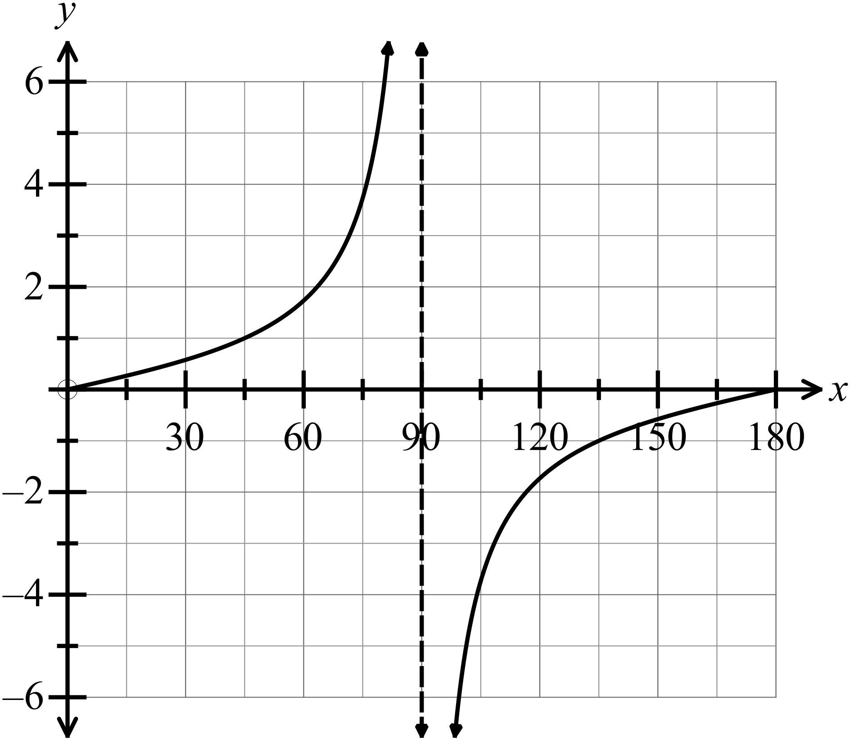

 | 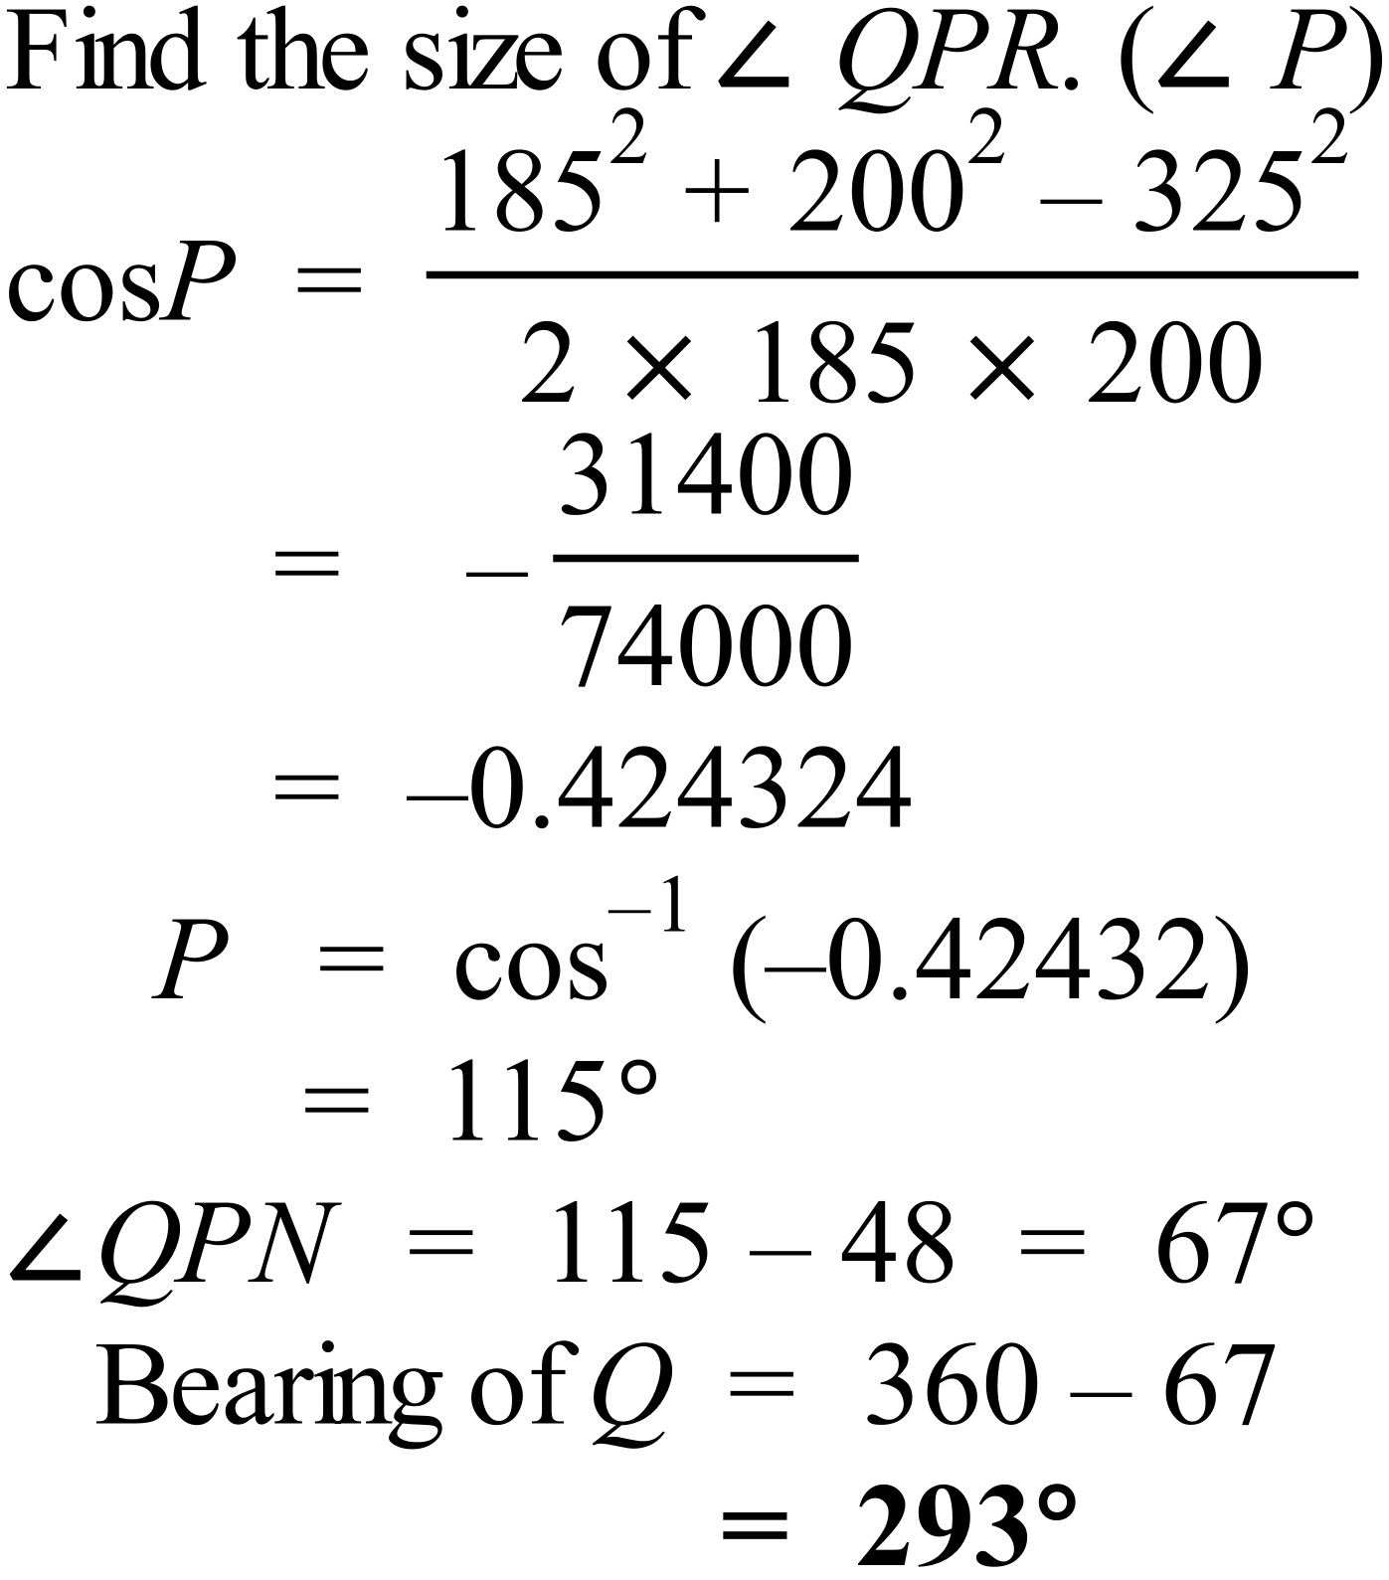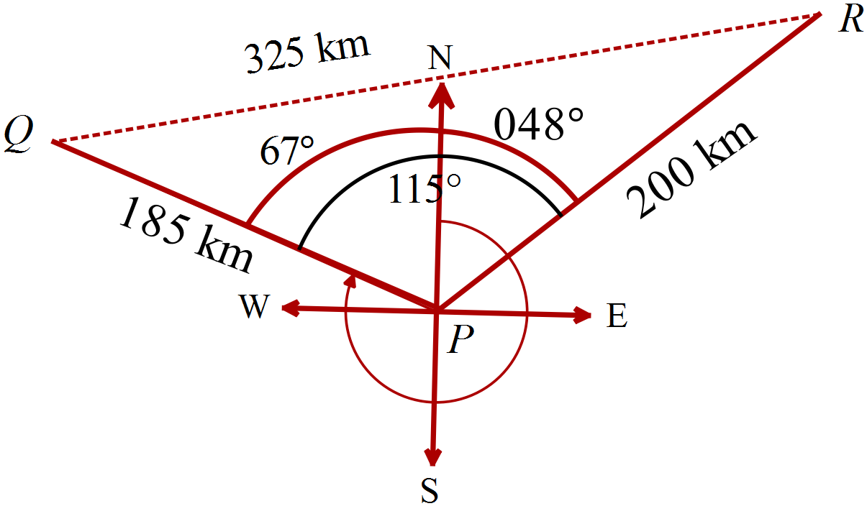
Recalling the sketch of 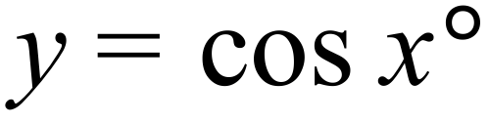
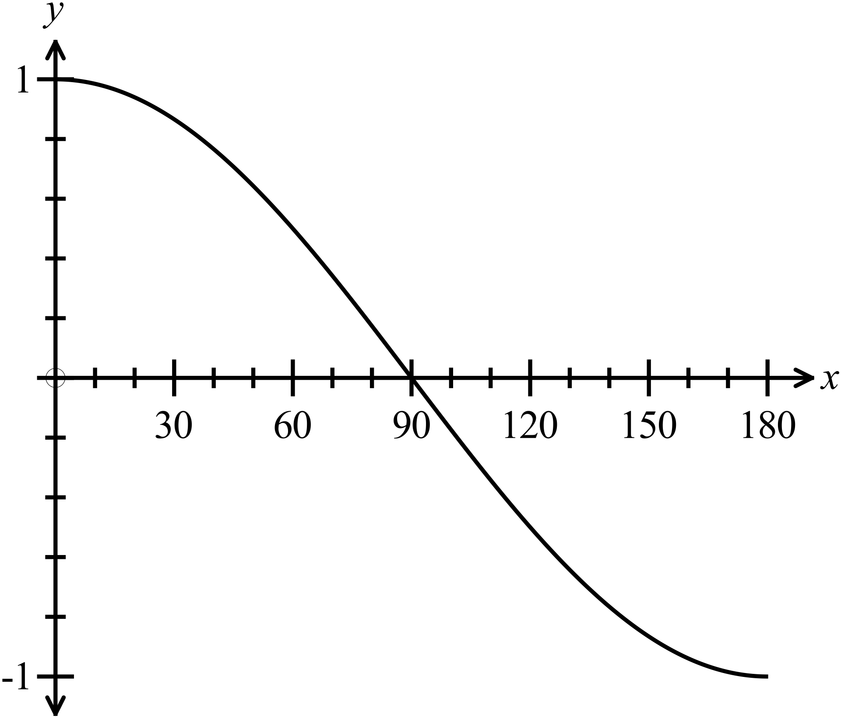

The only value is x = 0

 | 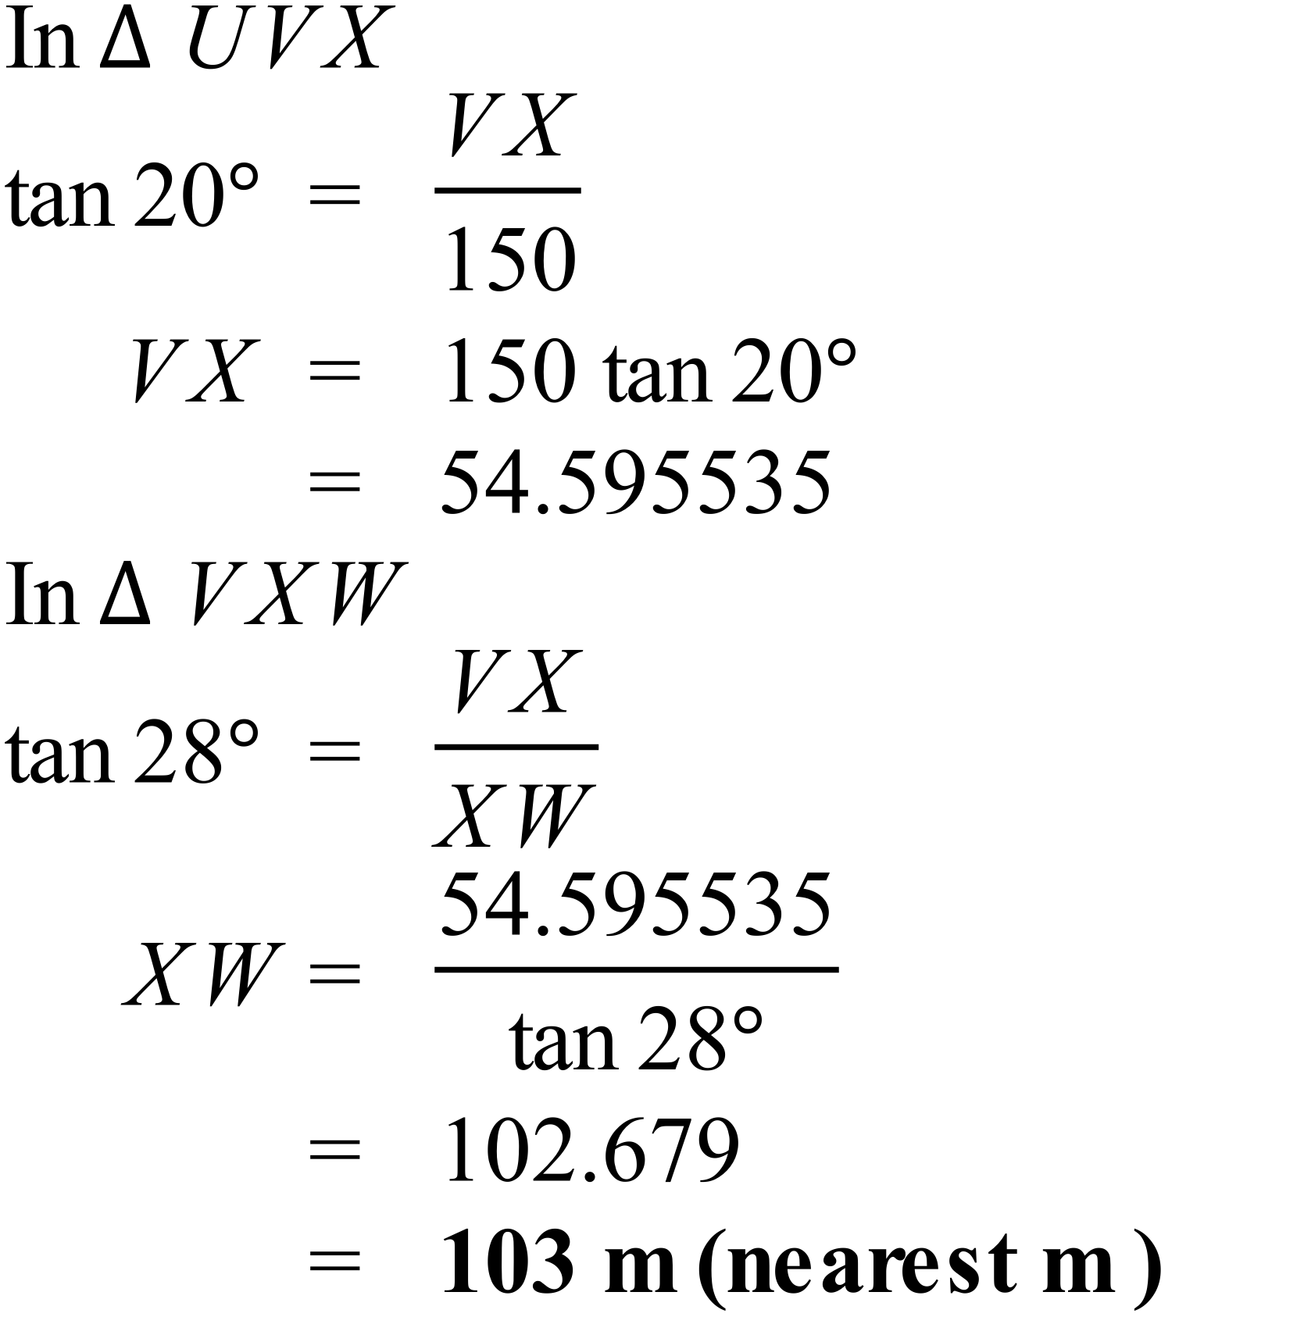

School Name
Mathematics Test 2017
Year 10 | Non-Right Triangle Trigonometry | Calculator Allowed  Multiple Choice  Section

ANSWERS

Question | Working | M C Answer
 | has the w and x terms in the wrong positions. | D
 | 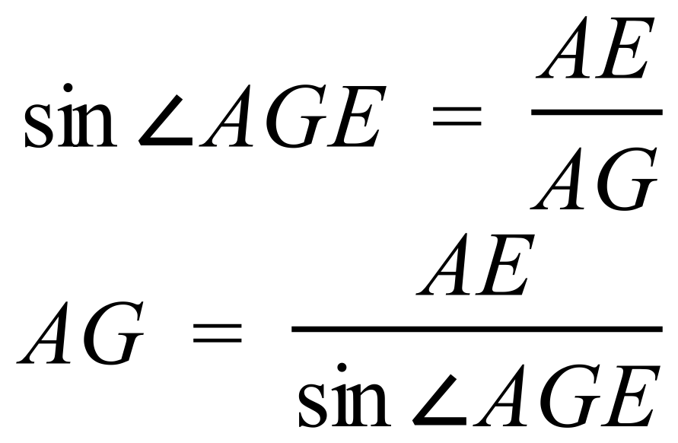 | B
 | 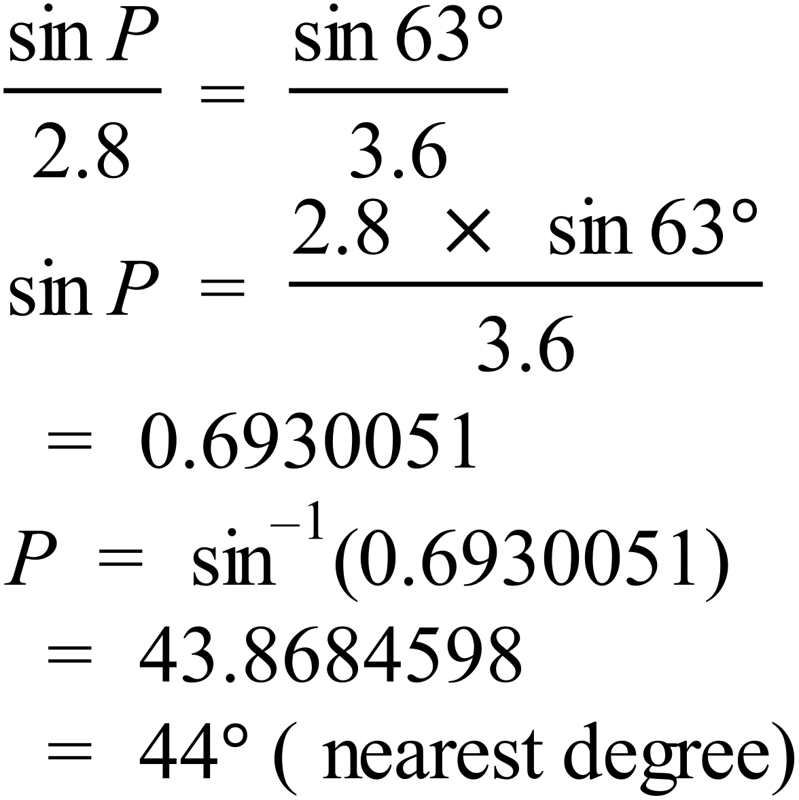 | C
 | 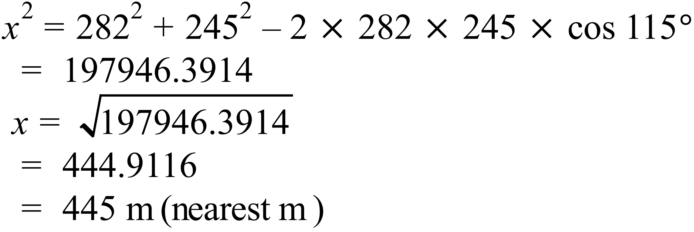 | D
 | Curve is a periodic wave, and has y =1 when x = 0, so since 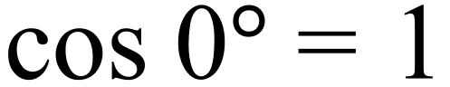, the graph could be | A
 | 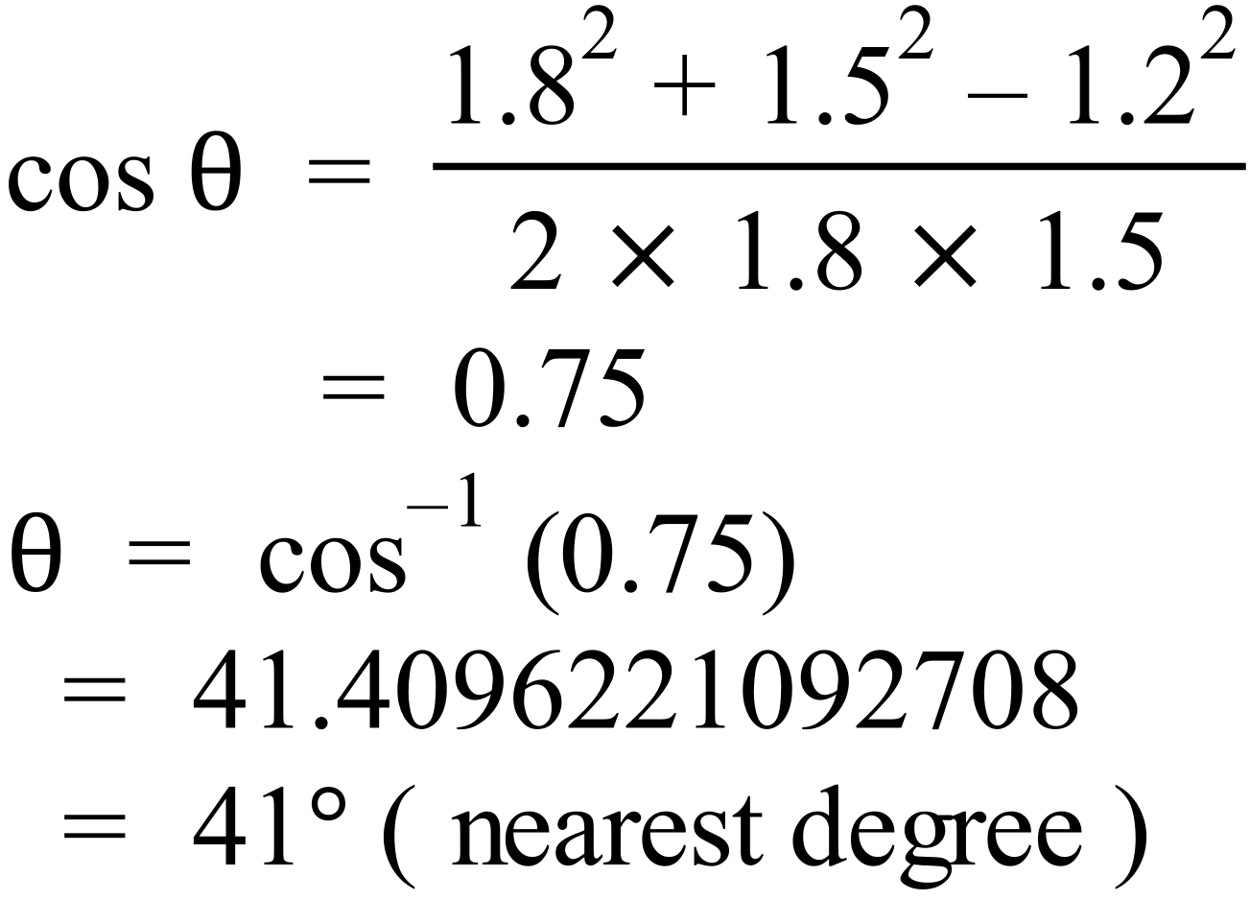 | B
 | 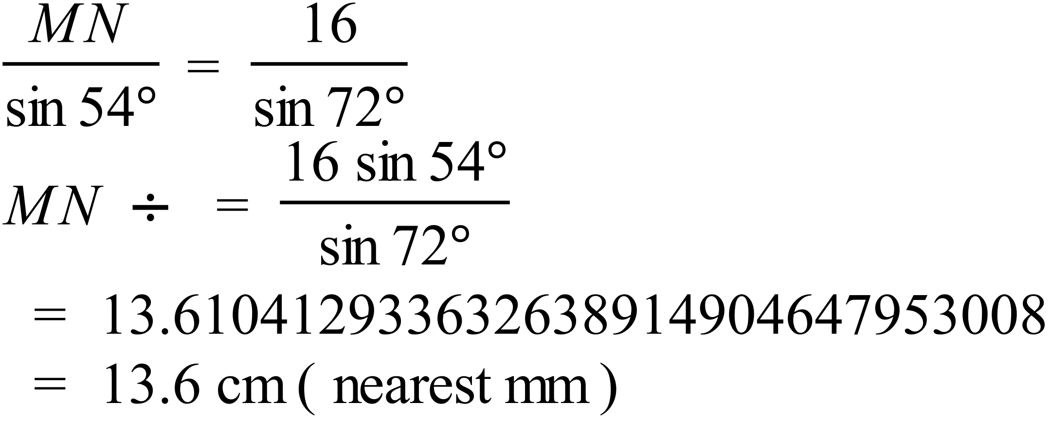 | C
 | 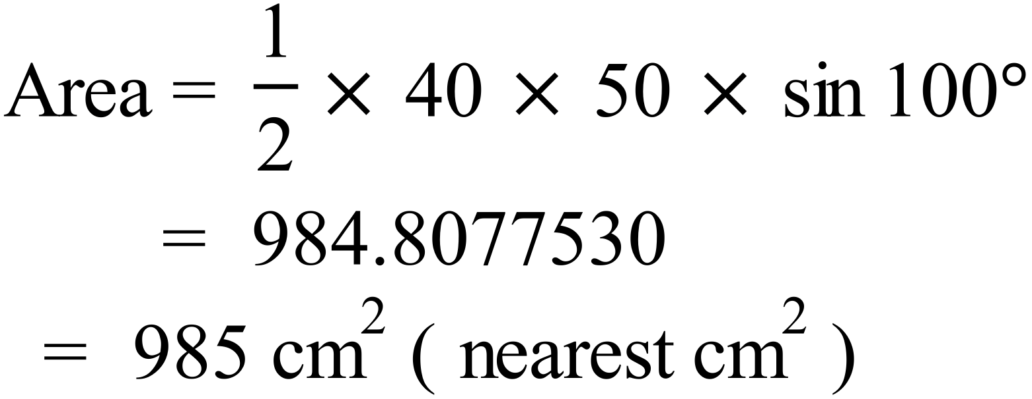 | A
 | 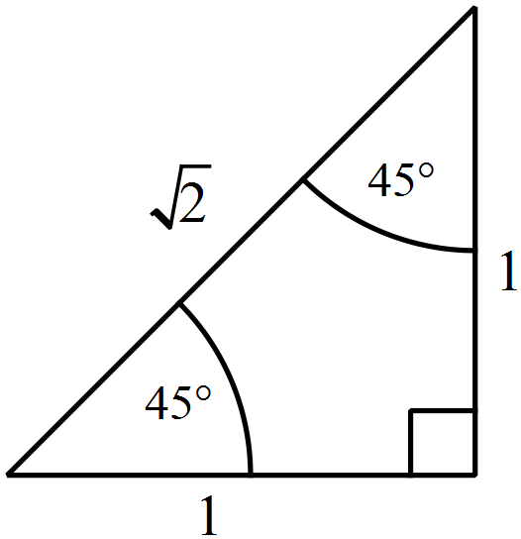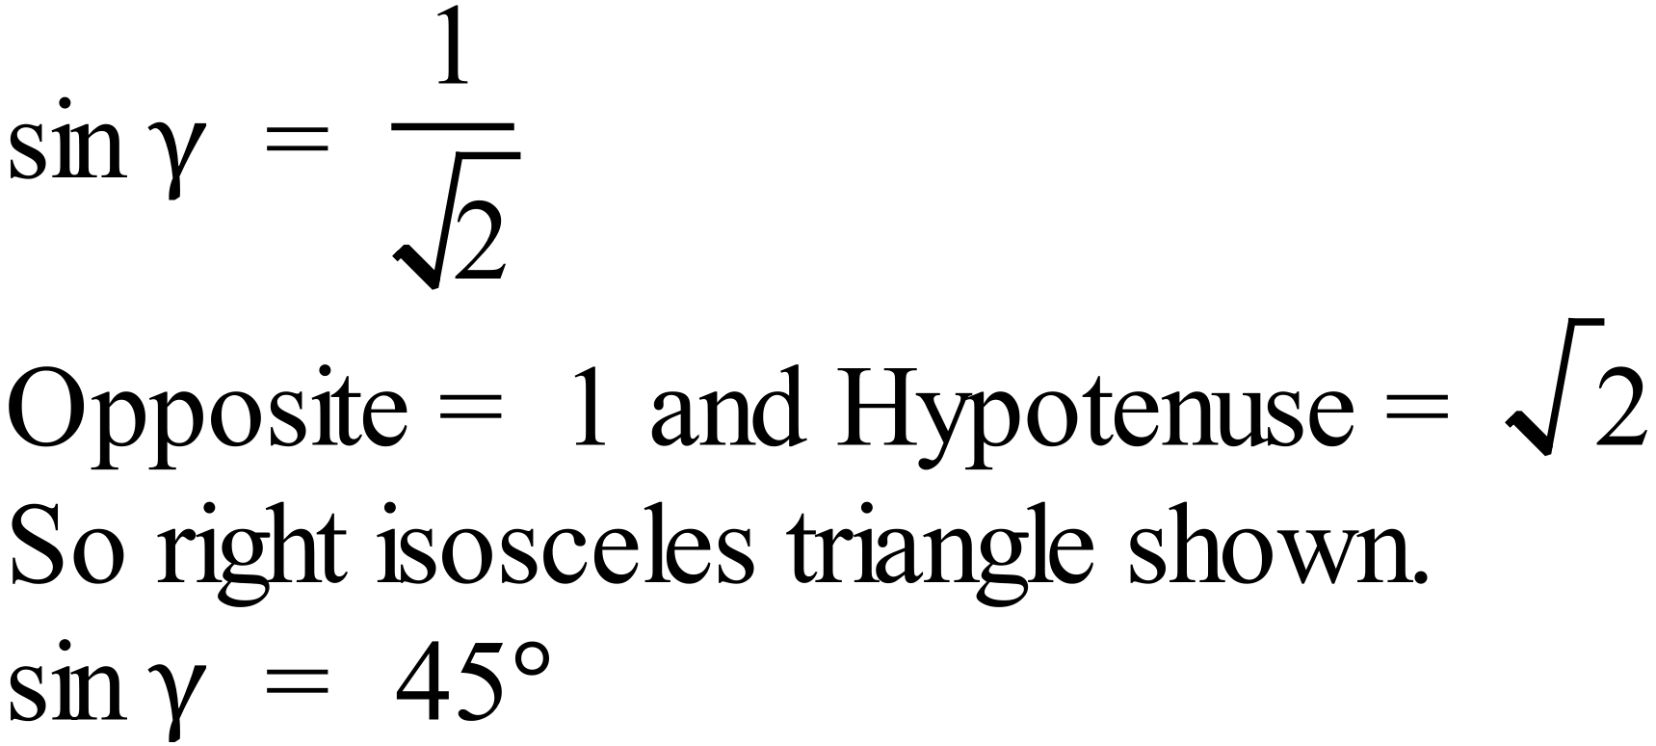 | C
 | 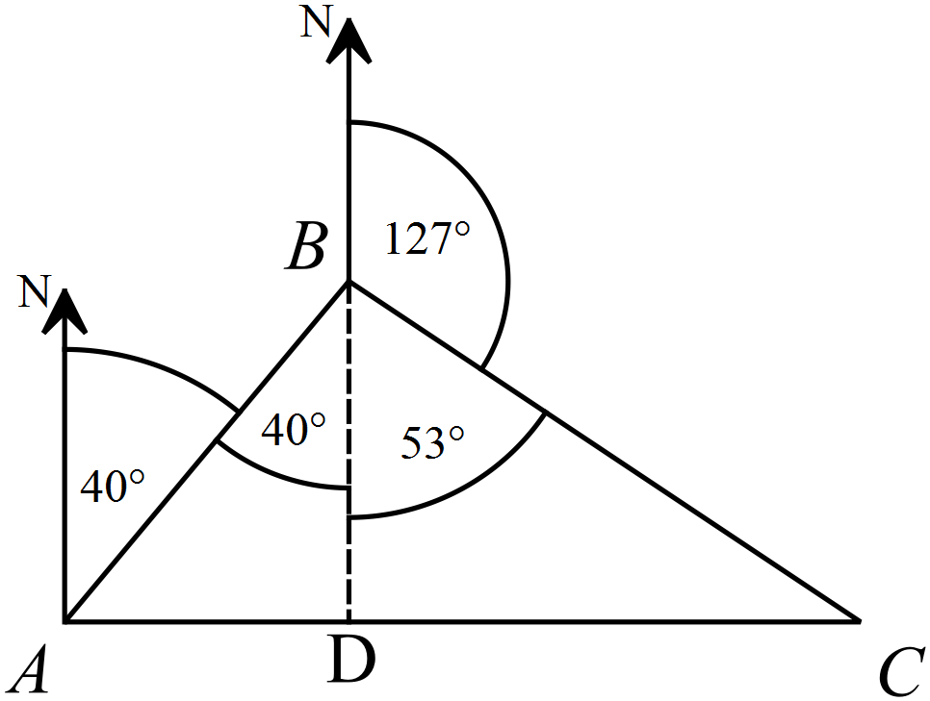Join BD so D is south of B.  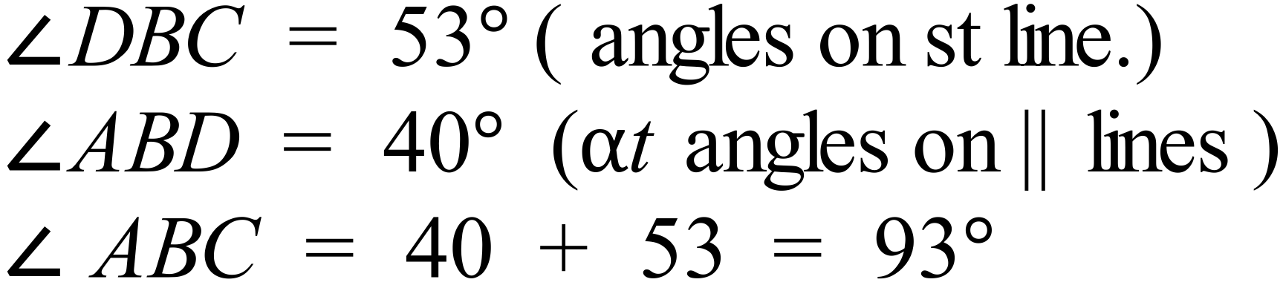 | D
 | 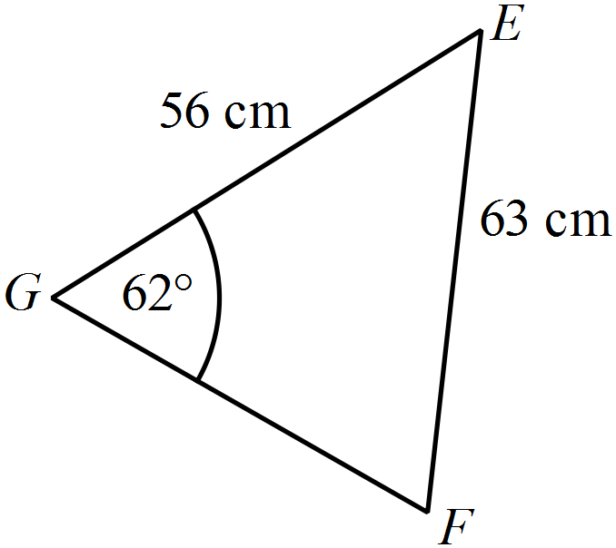  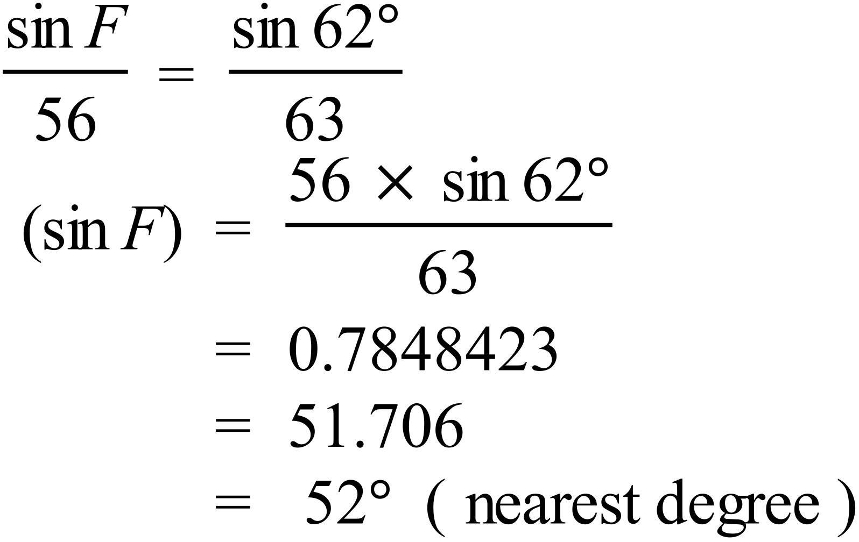 | B
 | 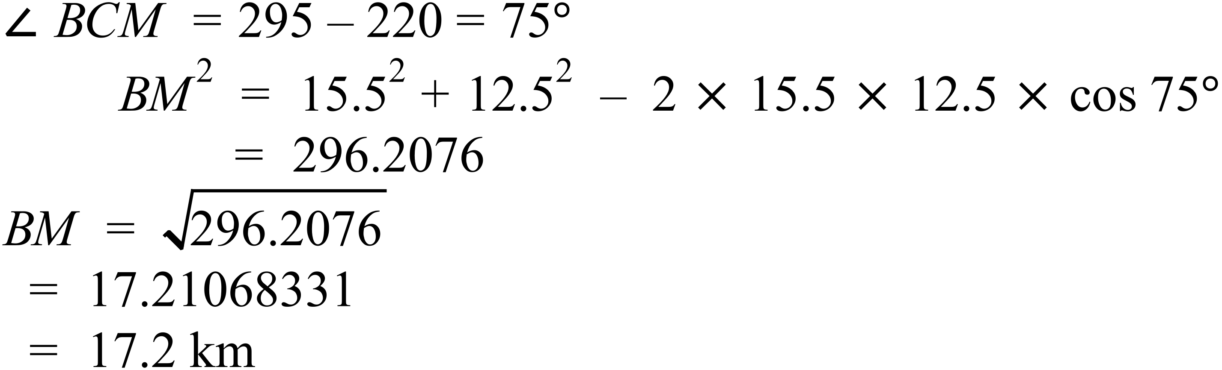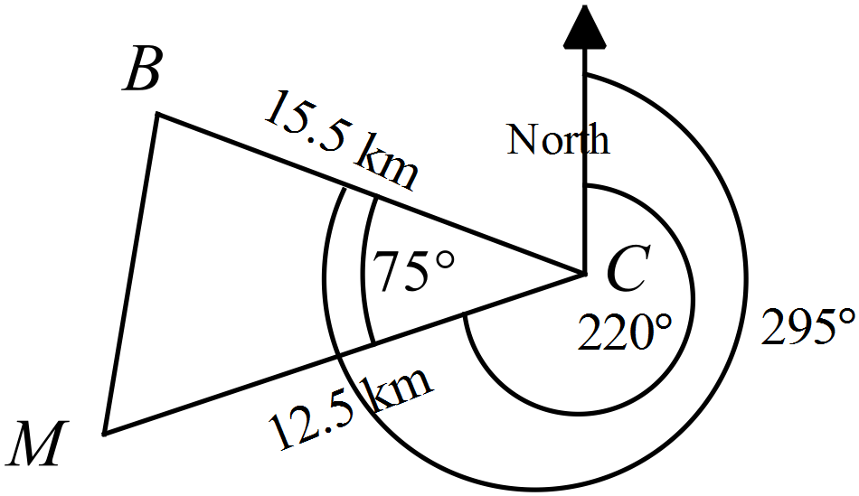 | C
 | 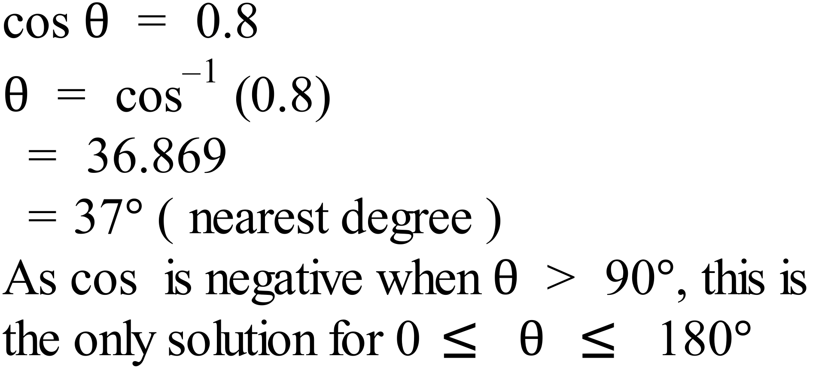 | A
 | 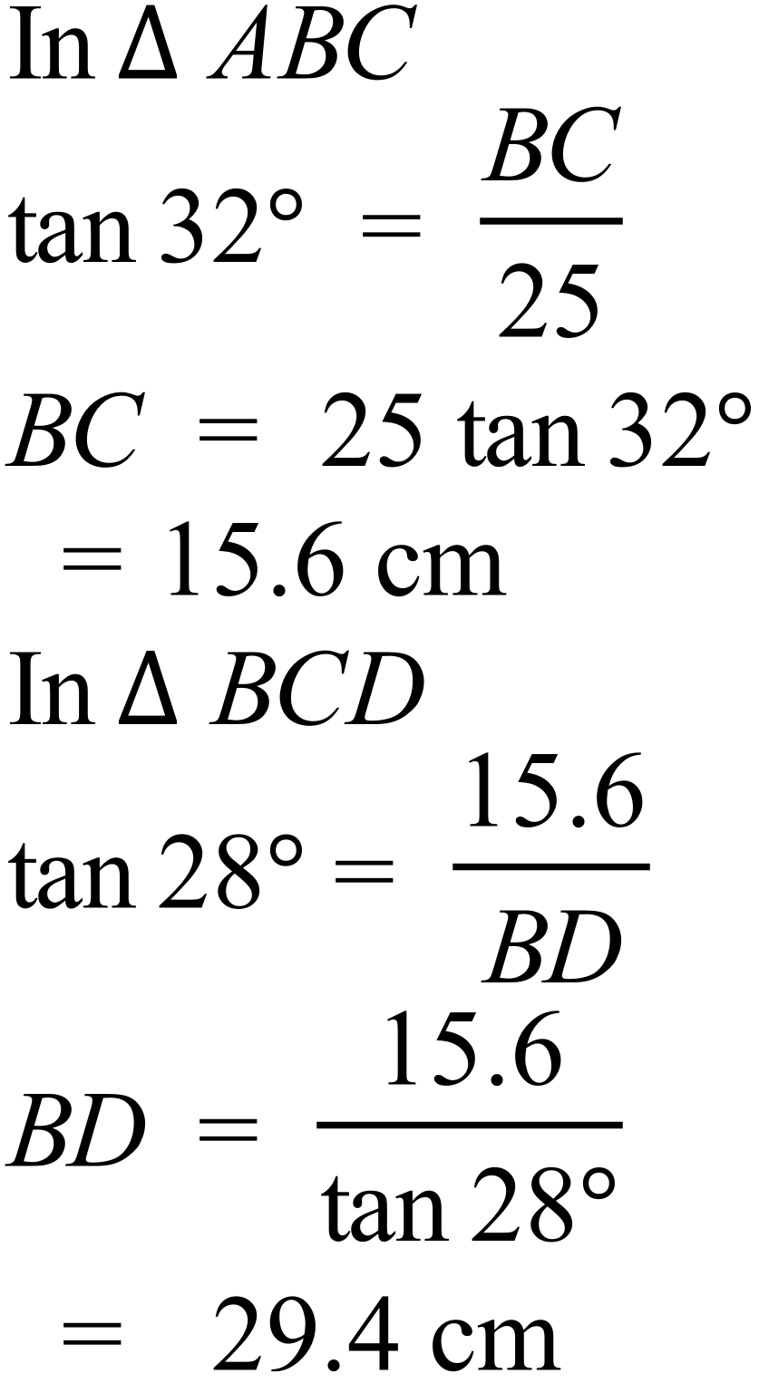 | D
 | 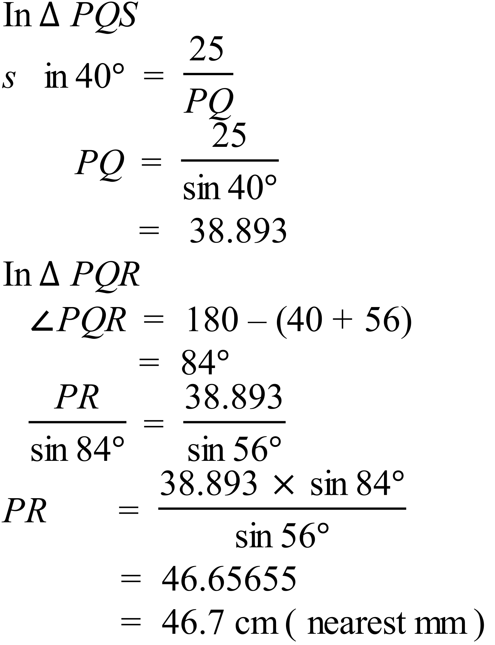 | D

School Name
Mathematics 2017
Multiple Choice Answer Sheet
Non-Right Triangle Trigonometry
Name _____________________________________________
Completely fill the response oval representing the most correct answer.
1. A B C D
2. A B C D
3. A B C D
4. A B C D
5. A B C D
6. A B C D
7. A B C D
8. A B C D
9. A B C D
10. A B C D
11. A B C D
12. A B C D
13. A B C D
14. A B C D
15. A B C D

